UNITED STATES
SECURITIES AND EXCHANGE COMMISSION
Washington, D.C. 20549
_____________

FORM 8-K
CURRENT REPORT
PURSUANT TO SECTION 13 OR 15(d) OF THE
SECURITIES EXCHANGE ACT OF 1934
Date of Report (Date of earliest event reported): October 22, 2026
Amalgamated Financial Corp.
(Exact name of registrant as specified in its charter)
Delaware |  |  |  |  |  | 001-40136 |  |  |  |  |  | 85-2757101
(State or other jurisdiction  of incorporation) |  |  |  |  |  | (Commission File Number) |  |  |  |  |  | (I.R.S. Employer Identification  No.)
99 Park Avenue, New York, New York 10016
(Address of principal executive offices) (Zip Code)
Registrant’s telephone number, including area code: (212) 895-8988
Not Applicable
(Former name or former address, if changed since last report)
Check the appropriate box below if the Form 8-K filing is intended to simultaneously satisfy the filing obligation of the registrant under any of the following provisions (see General Instruction A.2. below):
☐ Written communications pursuant to Rule 425 under the Securities Act (17 CFR 230.425)
☐ Soliciting material pursuant to Rule 14a-12 under the Exchange Act (17 CFR 240.14a-12)
☐ Pre-commencement communications pursuant to Rule 14d-2(b) under the Exchange Act (17 CFR 240.14d-2(b))
☐ Pre-commencement communications pursuant to Rule 13e-4(c) under the Exchange Act (17 CFR 240.13e-4(c))

Securities registered pursuant to Section 12(b) of the Act:
Title of each class |  |  | Trading Symbol(s) |  |  | Name of each exchange on which registered
Common Stock, par value $0.01 per share |  |  | AMAL |  |  | The Nasdaq Global Market

Indicate by check mark whether the registrant is an emerging growth company as defined in Rule 405 of the Securities Act of 1933 (17 CFR § 230.405) or Rule 12b-2 of the Securities Exchange Act of 1934 (17 CFR § 240.12b-2).

Emerging growth company ☐

If an emerging growth company, indicate by check mark if the registrant has elected not to use the extended transition period for complying with any new or revised financial accounting standards provided pursuant to Section 13(a) of the Exchange Act. ☐

Item 2.02 Results of Operations and Financial Condition.

On October 22, 2026, Amalgamated Financial Corp. (the "Company") issued a press release announcing financial results for the third quarter ended September 30, 2026. The press release is furnished as Exhibit 99.1 to this Current Report on Form 8-K.

The information in this Item 2.02, including Exhibit 99.1, shall not be deemed "filed" for purposes of Section 18 of the Securities Exchange Act of 1934, or otherwise subject to the liability of that section, and shall not be deemed to be incorporated by reference into any filing under the Securities Act of 1933 or the Securities Exchange Act of 1934.

Item 7.01 Regulation FD Disclosure.

On October 22, 2026, the Company will hold an earnings conference call and webcast at 11:00 a.m. (Eastern Time) to discuss financial results for the third quarter ended September 30, 2026. The press release contains information about how to access the conference call and webcast. A copy of the slide presentation to be used during the earnings call and webcast is furnished as Exhibit 99.2 to this Current Report on Form 8-K. The slide presentation is also available on our website, www.amalgamatedbank.com, under the “Investor Relations” section.

The information in this Item 7.01, including Exhibit 99.2, shall not be deemed "filed" for purposes of Section 18 of the Securities Exchange Act of 1934, or otherwise subject to the liability of that section, and shall not be deemed to be incorporated by reference into any filing under the Securities Act of 1933 or the Securities Exchange Act of 1934.

Item 9.01 Financial Statements and Exhibits

(d) Exhibits The following exhibit index lists the exhibits that are either filed or furnished with this Current Report on Form 8-K:
EXHIBIT INDEX

Exhibit No. |  |  | Description
99.1 |  |  | Press Release dated October 22, 2026.
99.2 |  |  | Slide Presentation
104 |  |  | The cover page from this Current Report on Form 8-K, formatted in Inline XBRL.

SIGNATURES
Pursuant to the requirements of the Securities Exchange Act of 1934, the registrant has duly caused this report to be signed on its behalf by the undersigned hereunto duly authorized.

 |  |  |  |  |  | AMALGAMATED FINANCIAL CORP.
 |  |  |  |  |  | By: |  |  | /s/ Priscilla Sims Brown
 |  |  |  |  |  | Name: |  |  | Priscilla Sims Brown
 |  |  |  |  |  | Title: |  |  | Chief Executive Officer
Date: October 22, 2026

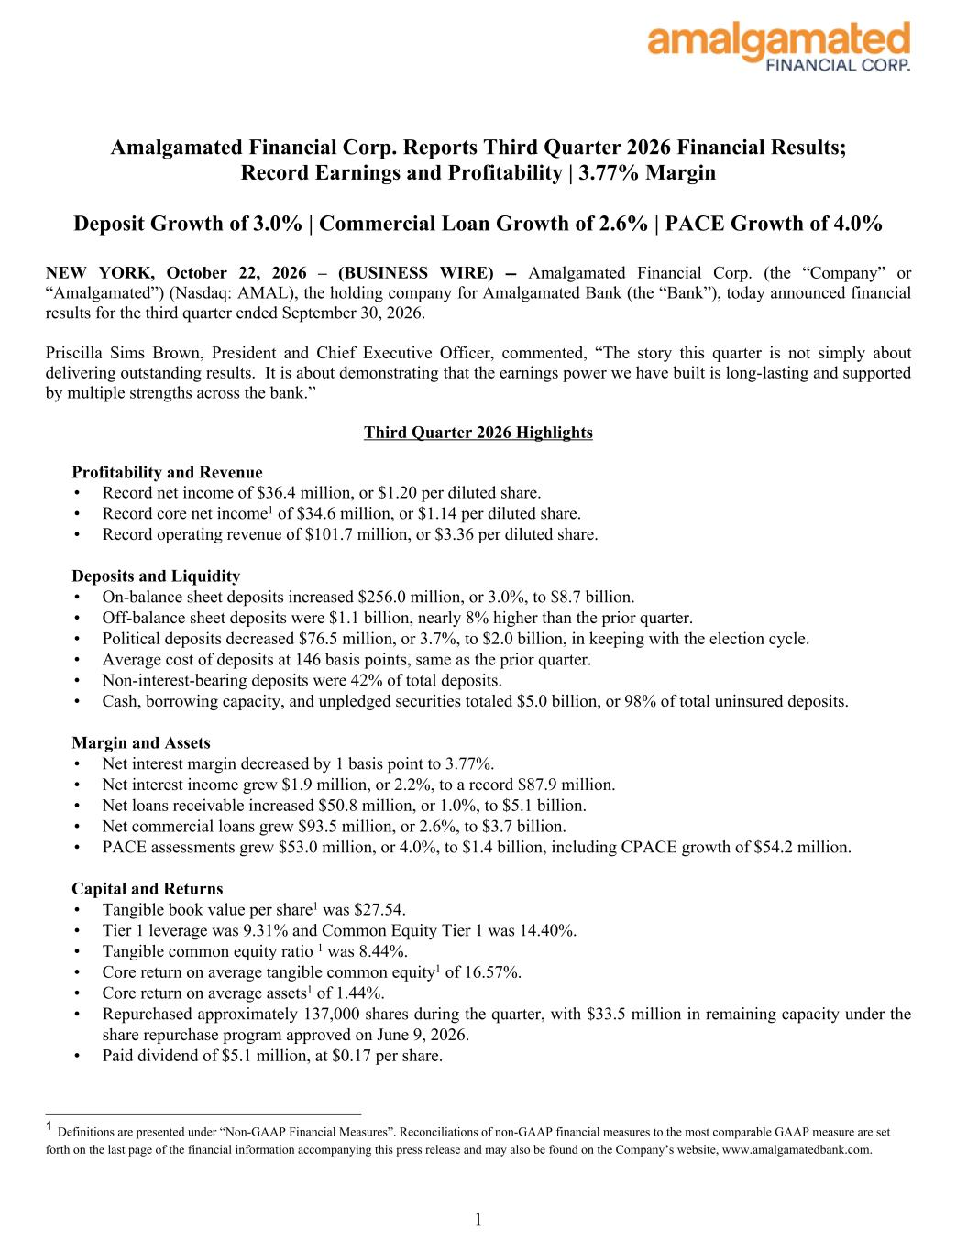

Amalgamated Financial Corp. Reports Third Quarter 2026 Financial Results; Record Earnings and Profitability | 3.77% Margin Deposit Growth of 3.0% | Commercial Loan Growth of 2.6% | PACE Growth of 4.0% NEW YORK, October 22, 2026 – (BUSINESS WIRE) -- Amalgamated Financial Corp. (the “Company” or “Amalgamated”) (Nasdaq: AMAL), the holding company for Amalgamated Bank (the “Bank”), today announced financial results for the third quarter ended September 30, 2026. Priscilla Sims Brown, President and Chief Executive Officer, commented, “The story this quarter is not simply about delivering outstanding results. It is about demonstrating that the earnings power we have built is long-lasting and supported by multiple strengths across the bank.” Third Quarter 2026 Highlights Profitability and Revenue • Record net income of $36.4 million, or $1.20 per diluted share. • Record core net income1 of $34.6 million, or $1.14 per diluted share. • Record operating revenue of $101.7 million, or $3.36 per diluted share. Deposits and Liquidity • On-balance sheet deposits increased $256.0 million, or 3.0%, to $8.7 billion. • Off-balance sheet deposits were $1.1 billion, nearly 8% higher than the prior quarter. • Political deposits decreased $76.5 million, or 3.7%, to $2.0 billion, in keeping with the election cycle. • Average cost of deposits at 146 basis points, same as the prior quarter. • Non-interest-bearing deposits were 42% of total deposits. • Cash, borrowing capacity, and unpledged securities totaled $5.0 billion, or 98% of total uninsured deposits. Margin and Assets • Net interest margin decreased by 1 basis point to 3.77%. • Net interest income grew $1.9 million, or 2.2%, to a record $87.9 million. • Net loans receivable increased $50.8 million, or 1.0%, to $5.1 billion. • Net commercial loans grew $93.5 million, or 2.6%, to $3.7 billion. • PACE assessments grew $53.0 million, or 4.0%, to $1.4 billion, including CPACE growth of $54.2 million. Capital and Returns • Tangible book value per share1 was $27.54. • Tier 1 leverage was 9.31% and Common Equity Tier 1 was 14.40%. • Tangible common equity ratio 1 was 8.44%. • Core return on average tangible common equity1 of 16.57%. • Core return on average assets1 of 1.44%. • Repurchased approximately 137,000 shares during the quarter, with $33.5 million in remaining capacity under the share repurchase program approved on June 9, 2026. • Paid dividend of $5.1 million, at $0.17 per share. 1 1 Definitions are presented under “Non-GAAP Financial Measures”. Reconciliations of non-GAAP financial measures to the most comparable GAAP measure are set forth on the last page of the financial information accompanying this press release and may also be found on the Company’s website, www.amalgamatedbank.com.

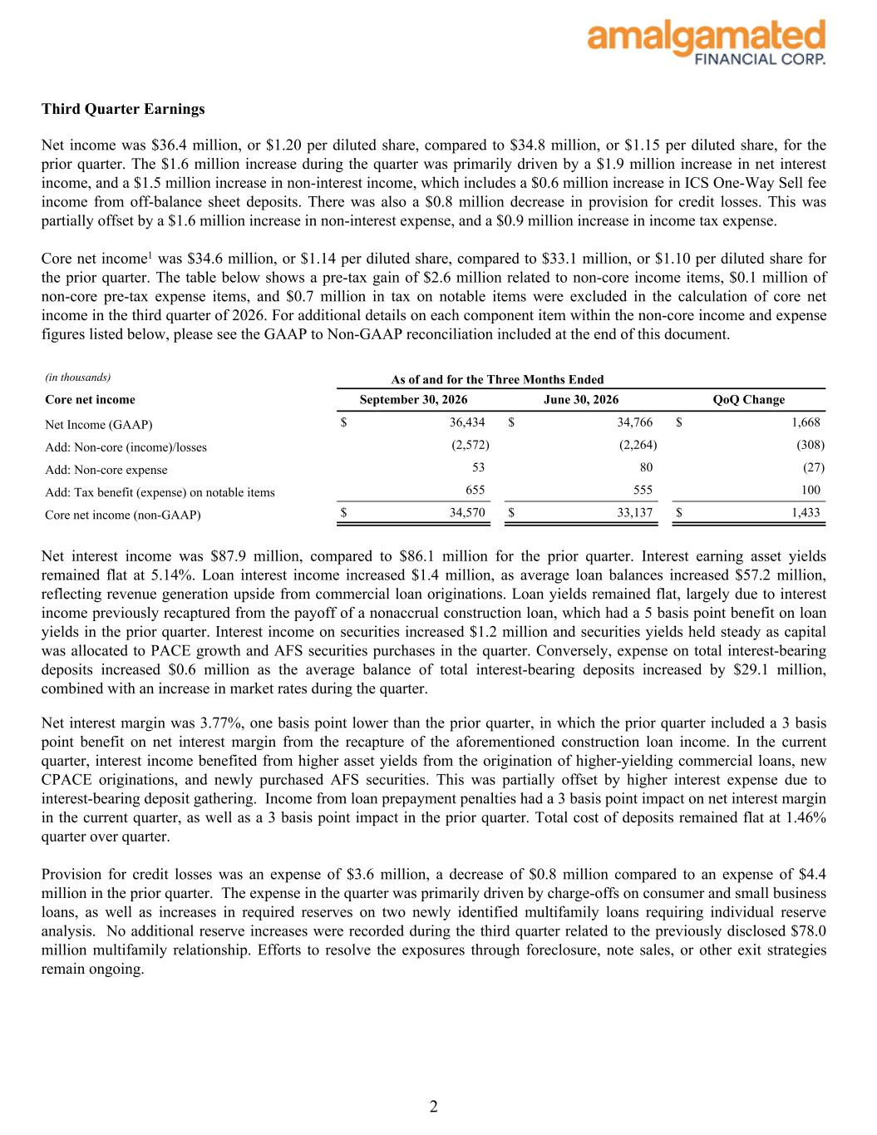
Third Quarter Earnings Net income was $36.4 million, or $1.20 per diluted share, compared to $34.8 million, or $1.15 per diluted share, for the prior quarter. The $1.6 million increase during the quarter was primarily driven by a $1.9 million increase in net interest income, and a $1.5 million increase in non-interest income, which includes a $0.6 million increase in ICS One-Way Sell fee income from off-balance sheet deposits. There was also a $0.8 million decrease in provision for credit losses. This was partially offset by a $1.6 million increase in non-interest expense, and a $0.9 million increase in income tax expense. Core net income1 was $34.6 million, or $1.14 per diluted share, compared to $33.1 million, or $1.10 per diluted share for the prior quarter. The table below shows a pre-tax gain of $2.6 million related to non-core income items, $0.1 million of non-core pre-tax expense items, and $0.7 million in tax on notable items were excluded in the calculation of core net income in the third quarter of 2026. For additional details on each component item within the non-core income and expense figures listed below, please see the GAAP to Non-GAAP reconciliation included at the end of this document. (in thousands) As of and for the Three Months Ended Core net income September 30, 2026 June 30, 2026 QoQ Change Net Income (GAAP) $ 36,434 $ 34,766 $ 1,668 Add: Non-core (income)/losses (2,572) (2,264) (308) Add: Non-core expense 53 80 (27) Add: Tax benefit (expense) on notable items 655 555 100 Core net income (non-GAAP) $ 34,570 $ 33,137 $ 1,433 Net interest income was $87.9 million, compared to $86.1 million for the prior quarter. Interest earning asset yields remained flat at 5.14%. Loan interest income increased $1.4 million, as average loan balances increased $57.2 million, reflecting revenue generation upside from commercial loan originations. Loan yields remained flat, largely due to interest income previously recaptured from the payoff of a nonaccrual construction loan, which had a 5 basis point benefit on loan yields in the prior quarter. Interest income on securities increased $1.2 million and securities yields held steady as capital was allocated to PACE growth and AFS securities purchases in the quarter. Conversely, expense on total interest-bearing deposits increased $0.6 million as the average balance of total interest-bearing deposits increased by $29.1 million, combined with an increase in market rates during the quarter. Net interest margin was 3.77%, one basis point lower than the prior quarter, in which the prior quarter included a 3 basis point benefit on net interest margin from the recapture of the aforementioned construction loan income. In the current quarter, interest income benefited from higher asset yields from the origination of higher-yielding commercial loans, new CPACE originations, and newly purchased AFS securities. This was partially offset by higher interest expense due to interest-bearing deposit gathering. Income from loan prepayment penalties had a 3 basis point impact on net interest margin in the current quarter, as well as a 3 basis point impact in the prior quarter. Total cost of deposits remained flat at 1.46% quarter over quarter. Provision for credit losses was an expense of $3.6 million, a decrease of $0.8 million compared to an expense of $4.4 million in the prior quarter. The expense in the quarter was primarily driven by charge-offs on consumer and small business loans, as well as increases in required reserves on two newly identified multifamily loans requiring individual reserve analysis. No additional reserve increases were recorded during the third quarter related to the previously disclosed $78.0 million multifamily relationship. Efforts to resolve the exposures through foreclosure, note sales, or other exit strategies remain ongoing. 2

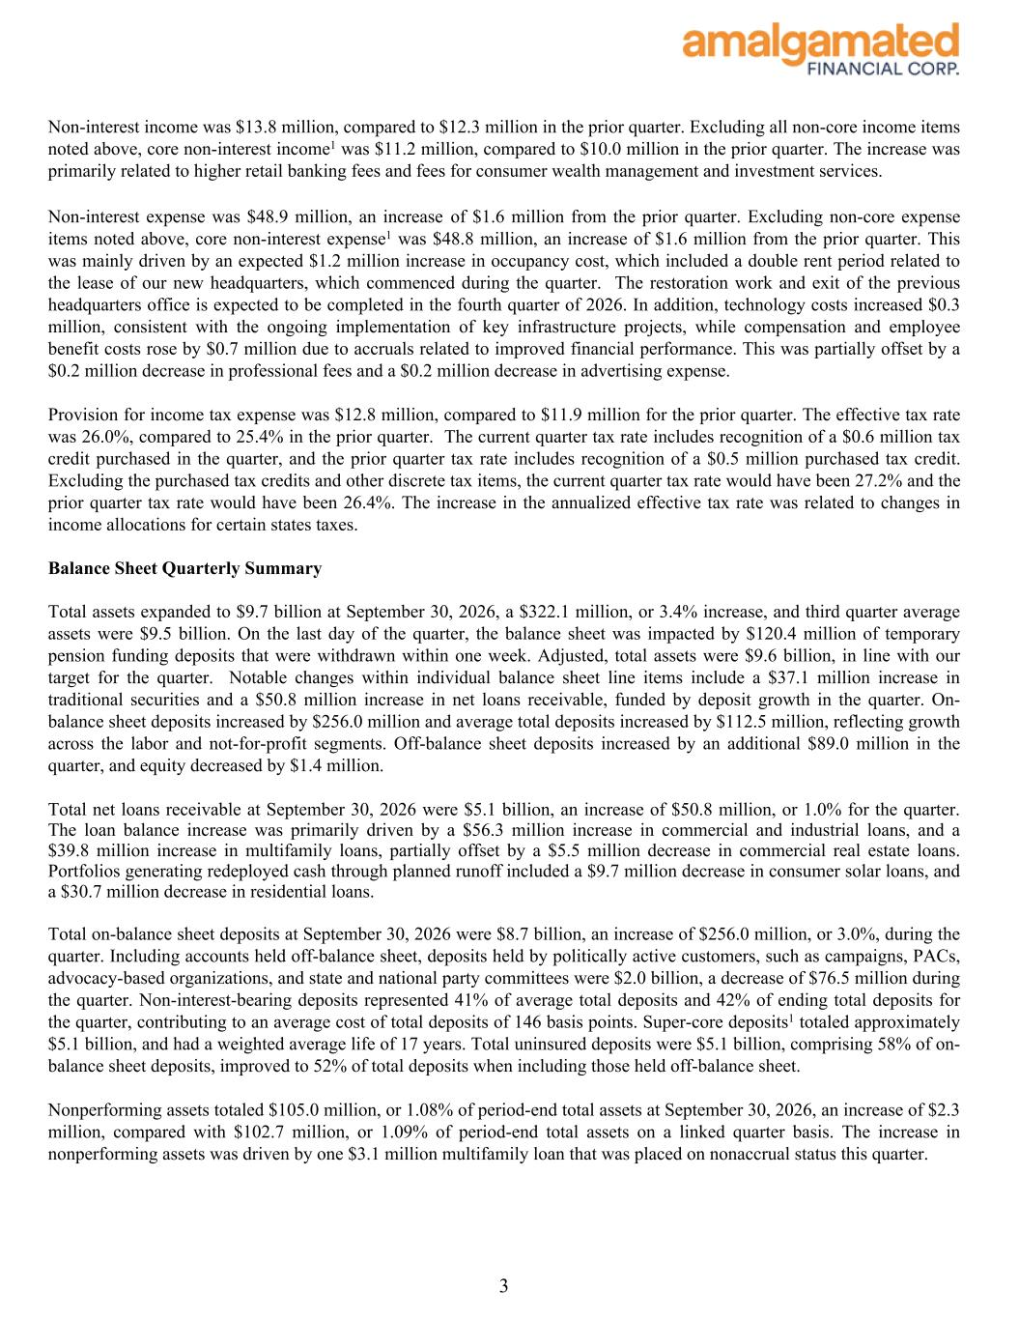
Non-interest income was $13.8 million, compared to $12.3 million in the prior quarter. Excluding all non-core income items noted above, core non-interest income1 was $11.2 million, compared to $10.0 million in the prior quarter. The increase was primarily related to higher retail banking fees and fees for consumer wealth management and investment services. Non-interest expense was $48.9 million, an increase of $1.6 million from the prior quarter. Excluding non-core expense items noted above, core non-interest expense1 was $48.8 million, an increase of $1.6 million from the prior quarter. This was mainly driven by an expected $1.2 million increase in occupancy cost, which included a double rent period related to the lease of our new headquarters, which commenced during the quarter. The restoration work and exit of the previous headquarters office is expected to be completed in the fourth quarter of 2026. In addition, technology costs increased $0.3 million, consistent with the ongoing implementation of key infrastructure projects, while compensation and employee benefit costs rose by $0.7 million due to accruals related to improved financial performance. This was partially offset by a $0.2 million decrease in professional fees and a $0.2 million decrease in advertising expense. Provision for income tax expense was $12.8 million, compared to $11.9 million for the prior quarter. The effective tax rate was 26.0%, compared to 25.4% in the prior quarter. The current quarter tax rate includes recognition of a $0.6 million tax credit purchased in the quarter, and the prior quarter tax rate includes recognition of a $0.5 million purchased tax credit. Excluding the purchased tax credits and other discrete tax items, the current quarter tax rate would have been 27.2% and the prior quarter tax rate would have been 26.4%. The increase in the annualized effective tax rate was related to changes in income allocations for certain states taxes. Balance Sheet Quarterly Summary Total assets expanded to $9.7 billion at September 30, 2026, a $322.1 million, or 3.4% increase, and third quarter average assets were $9.5 billion. On the last day of the quarter, the balance sheet was impacted by $120.4 million of temporary pension funding deposits that were withdrawn within one week. Adjusted, total assets were $9.6 billion, in line with our target for the quarter. Notable changes within individual balance sheet line items include a $37.1 million increase in traditional securities and a $50.8 million increase in net loans receivable, funded by deposit growth in the quarter. On- balance sheet deposits increased by $256.0 million and average total deposits increased by $112.5 million, reflecting growth across the labor and not-for-profit segments. Off-balance sheet deposits increased by an additional $89.0 million in the quarter, and equity decreased by $1.4 million. Total net loans receivable at September 30, 2026 were $5.1 billion, an increase of $50.8 million, or 1.0% for the quarter. The loan balance increase was primarily driven by a $56.3 million increase in commercial and industrial loans, and a $39.8 million increase in multifamily loans, partially offset by a $5.5 million decrease in commercial real estate loans. Portfolios generating redeployed cash through planned runoff included a $9.7 million decrease in consumer solar loans, and a $30.7 million decrease in residential loans. Total on-balance sheet deposits at September 30, 2026 were $8.7 billion, an increase of $256.0 million, or 3.0%, during the quarter. Including accounts held off-balance sheet, deposits held by politically active customers, such as campaigns, PACs, advocacy-based organizations, and state and national party committees were $2.0 billion, a decrease of $76.5 million during the quarter. Non-interest-bearing deposits represented 41% of average total deposits and 42% of ending total deposits for the quarter, contributing to an average cost of total deposits of 146 basis points. Super-core deposits1 totaled approximately $5.1 billion, and had a weighted average life of 17 years. Total uninsured deposits were $5.1 billion, comprising 58% of on- balance sheet deposits, improved to 52% of total deposits when including those held off-balance sheet. Nonperforming assets totaled $105.0 million, or 1.08% of period-end total assets at September 30, 2026, an increase of $2.3 million, compared with $102.7 million, or 1.09% of period-end total assets on a linked quarter basis. The increase in nonperforming assets was driven by one $3.1 million multifamily loan that was placed on nonaccrual status this quarter. 3

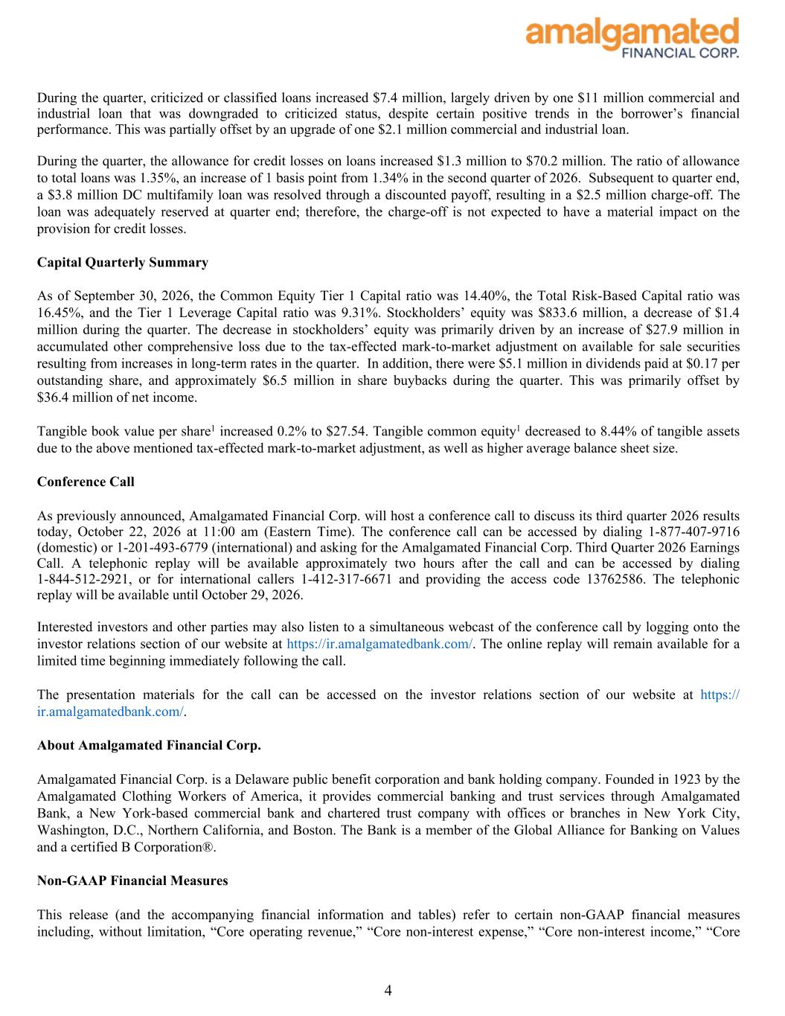
During the quarter, criticized or classified loans increased $7.4 million, largely driven by one $11 million commercial and industrial loan that was downgraded to criticized status, despite certain positive trends in the borrower’s financial performance. This was partially offset by an upgrade of one $2.1 million commercial and industrial loan. During the quarter, the allowance for credit losses on loans increased $1.3 million to $70.2 million. The ratio of allowance to total loans was 1.35%, an increase of 1 basis point from 1.34% in the second quarter of 2026. Subsequent to quarter end, a $3.8 million DC multifamily loan was resolved through a discounted payoff, resulting in a $2.5 million charge-off. The loan was adequately reserved at quarter end; therefore, the charge-off is not expected to have a material impact on the provision for credit losses. Capital Quarterly Summary As of September 30, 2026, the Common Equity Tier 1 Capital ratio was 14.40%, the Total Risk-Based Capital ratio was 16.45%, and the Tier 1 Leverage Capital ratio was 9.31%. Stockholders’ equity was $833.6 million, a decrease of $1.4 million during the quarter. The decrease in stockholders’ equity was primarily driven by an increase of $27.9 million in accumulated other comprehensive loss due to the tax-effected mark-to-market adjustment on available for sale securities resulting from increases in long-term rates in the quarter. In addition, there were $5.1 million in dividends paid at $0.17 per outstanding share, and approximately $6.5 million in share buybacks during the quarter. This was primarily offset by $36.4 million of net income. Tangible book value per share1 increased 0.2% to $27.54. Tangible common equity1 decreased to 8.44% of tangible assets due to the above mentioned tax-effected mark-to-market adjustment, as well as higher average balance sheet size. Conference Call As previously announced, Amalgamated Financial Corp. will host a conference call to discuss its third quarter 2026 results today, October 22, 2026 at 11:00 am (Eastern Time). The conference call can be accessed by dialing 1-877-407-9716 (domestic) or 1-201-493-6779 (international) and asking for the Amalgamated Financial Corp. Third Quarter 2026 Earnings Call. A telephonic replay will be available approximately two hours after the call and can be accessed by dialing 1-844-512-2921, or for international callers 1-412-317-6671 and providing the access code 13762586. The telephonic replay will be available until October 29, 2026. Interested investors and other parties may also listen to a simultaneous webcast of the conference call by logging onto the investor relations section of our website at https://ir.amalgamatedbank.com/. The online replay will remain available for a limited time beginning immediately following the call. The presentation materials for the call can be accessed on the investor relations section of our website at https:// ir.amalgamatedbank.com/. About Amalgamated Financial Corp. Amalgamated Financial Corp. is a Delaware public benefit corporation and bank holding company. Founded in 1923 by the Amalgamated Clothing Workers of America, it provides commercial banking and trust services through Amalgamated Bank, a New York-based commercial bank and chartered trust company with offices or branches in New York City, Washington, D.C., Northern California, and Boston. The Bank is a member of the Global Alliance for Banking on Values and a certified B Corporation®. Non-GAAP Financial Measures This release (and the accompanying financial information and tables) refer to certain non-GAAP financial measures including, without limitation, “Core operating revenue,” “Core non-interest expense,” “Core non-interest income,” “Core 4

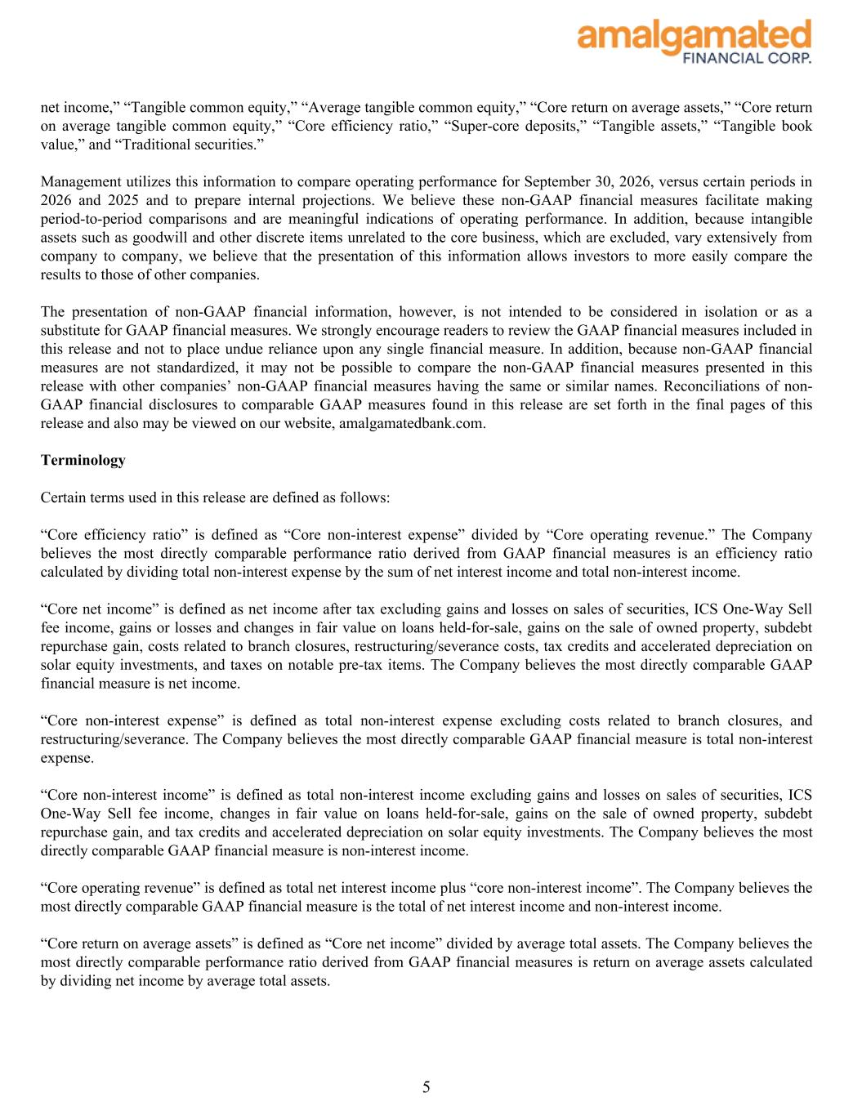
net income,” “Tangible common equity,” “Average tangible common equity,” “Core return on average assets,” “Core return on average tangible common equity,” “Core efficiency ratio,” “Super-core deposits,” “Tangible assets,” “Tangible book value,” and “Traditional securities.” Management utilizes this information to compare operating performance for September 30, 2026, versus certain periods in 2026 and 2025 and to prepare internal projections. We believe these non-GAAP financial measures facilitate making period-to-period comparisons and are meaningful indications of operating performance. In addition, because intangible assets such as goodwill and other discrete items unrelated to the core business, which are excluded, vary extensively from company to company, we believe that the presentation of this information allows investors to more easily compare the results to those of other companies. The presentation of non-GAAP financial information, however, is not intended to be considered in isolation or as a substitute for GAAP financial measures. We strongly encourage readers to review the GAAP financial measures included in this release and not to place undue reliance upon any single financial measure. In addition, because non-GAAP financial measures are not standardized, it may not be possible to compare the non-GAAP financial measures presented in this release with other companies’ non-GAAP financial measures having the same or similar names. Reconciliations of non- GAAP financial disclosures to comparable GAAP measures found in this release are set forth in the final pages of this release and also may be viewed on our website, amalgamatedbank.com. Terminology Certain terms used in this release are defined as follows: “Core efficiency ratio” is defined as “Core non-interest expense” divided by “Core operating revenue.” The Company believes the most directly comparable performance ratio derived from GAAP financial measures is an efficiency ratio calculated by dividing total non-interest expense by the sum of net interest income and total non-interest income. “Core net income” is defined as net income after tax excluding gains and losses on sales of securities, ICS One-Way Sell fee income, gains or losses and changes in fair value on loans held-for-sale, gains on the sale of owned property, subdebt repurchase gain, costs related to branch closures, restructuring/severance costs, tax credits and accelerated depreciation on solar equity investments, and taxes on notable pre-tax items. The Company believes the most directly comparable GAAP financial measure is net income. “Core non-interest expense” is defined as total non-interest expense excluding costs related to branch closures, and restructuring/severance. The Company believes the most directly comparable GAAP financial measure is total non-interest expense. “Core non-interest income” is defined as total non-interest income excluding gains and losses on sales of securities, ICS One-Way Sell fee income, changes in fair value on loans held-for-sale, gains on the sale of owned property, subdebt repurchase gain, and tax credits and accelerated depreciation on solar equity investments. The Company believes the most directly comparable GAAP financial measure is non-interest income. “Core operating revenue” is defined as total net interest income plus “core non-interest income”. The Company believes the most directly comparable GAAP financial measure is the total of net interest income and non-interest income. “Core return on average assets” is defined as “Core net income” divided by average total assets. The Company believes the most directly comparable performance ratio derived from GAAP financial measures is return on average assets calculated by dividing net income by average total assets. 5

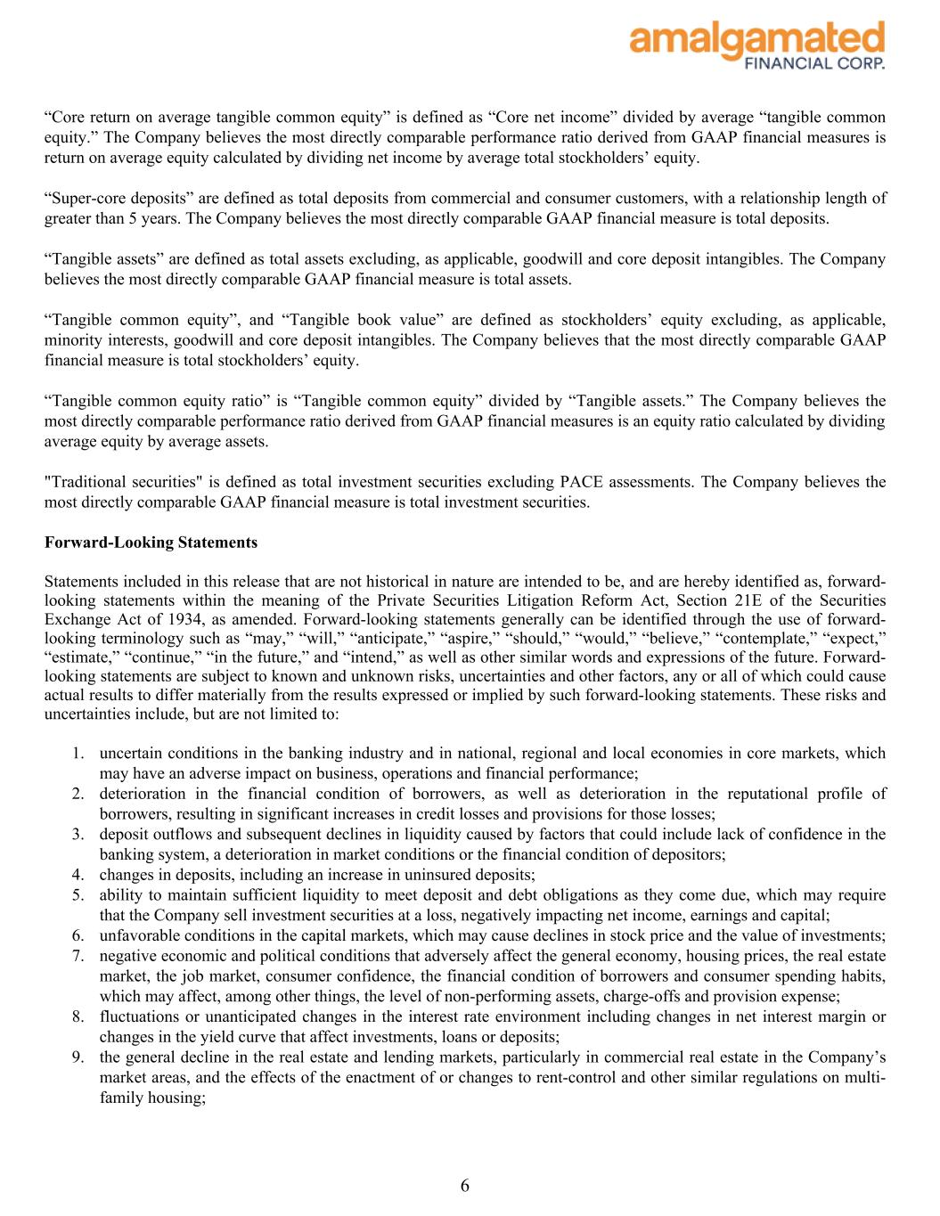
“Core return on average tangible common equity” is defined as “Core net income” divided by average “tangible common equity.” The Company believes the most directly comparable performance ratio derived from GAAP financial measures is return on average equity calculated by dividing net income by average total stockholders’ equity. “Super-core deposits” are defined as total deposits from commercial and consumer customers, with a relationship length of greater than 5 years. The Company believes the most directly comparable GAAP financial measure is total deposits. “Tangible assets” are defined as total assets excluding, as applicable, goodwill and core deposit intangibles. The Company believes the most directly comparable GAAP financial measure is total assets. “Tangible common equity”, and “Tangible book value” are defined as stockholders’ equity excluding, as applicable, minority interests, goodwill and core deposit intangibles. The Company believes that the most directly comparable GAAP financial measure is total stockholders’ equity. “Tangible common equity ratio” is “Tangible common equity” divided by “Tangible assets.” The Company believes the most directly comparable performance ratio derived from GAAP financial measures is an equity ratio calculated by dividing average equity by average assets. "Traditional securities" is defined as total investment securities excluding PACE assessments. The Company believes the most directly comparable GAAP financial measure is total investment securities. Forward-Looking Statements Statements included in this release that are not historical in nature are intended to be, and are hereby identified as, forward- looking statements within the meaning of the Private Securities Litigation Reform Act, Section 21E of the Securities Exchange Act of 1934, as amended. Forward-looking statements generally can be identified through the use of forward- looking terminology such as “may,” “will,” “anticipate,” “aspire,” “should,” “would,” “believe,” “contemplate,” “expect,” “estimate,” “continue,” “in the future,” and “intend,” as well as other similar words and expressions of the future. Forward- looking statements are subject to known and unknown risks, uncertainties and other factors, any or all of which could cause actual results to differ materially from the results expressed or implied by such forward-looking statements. These risks and uncertainties include, but are not limited to: 1. uncertain conditions in the banking industry and in national, regional and local economies in core markets, which may have an adverse impact on business, operations and financial performance; 2. deterioration in the financial condition of borrowers, as well as deterioration in the reputational profile of borrowers, resulting in significant increases in credit losses and provisions for those losses; 3. deposit outflows and subsequent declines in liquidity caused by factors that could include lack of confidence in the banking system, a deterioration in market conditions or the financial condition of depositors; 4. changes in deposits, including an increase in uninsured deposits; 5. ability to maintain sufficient liquidity to meet deposit and debt obligations as they come due, which may require that the Company sell investment securities at a loss, negatively impacting net income, earnings and capital; 6. unfavorable conditions in the capital markets, which may cause declines in stock price and the value of investments; 7. negative economic and political conditions that adversely affect the general economy, housing prices, the real estate market, the job market, consumer confidence, the financial condition of borrowers and consumer spending habits, which may affect, among other things, the level of non-performing assets, charge-offs and provision expense; 8. fluctuations or unanticipated changes in the interest rate environment including changes in net interest margin or changes in the yield curve that affect investments, loans or deposits; 9. the general decline in the real estate and lending markets, particularly in commercial real estate in the Company’s market areas, and the effects of the enactment of or changes to rent-control and other similar regulations on multi- family housing; 6

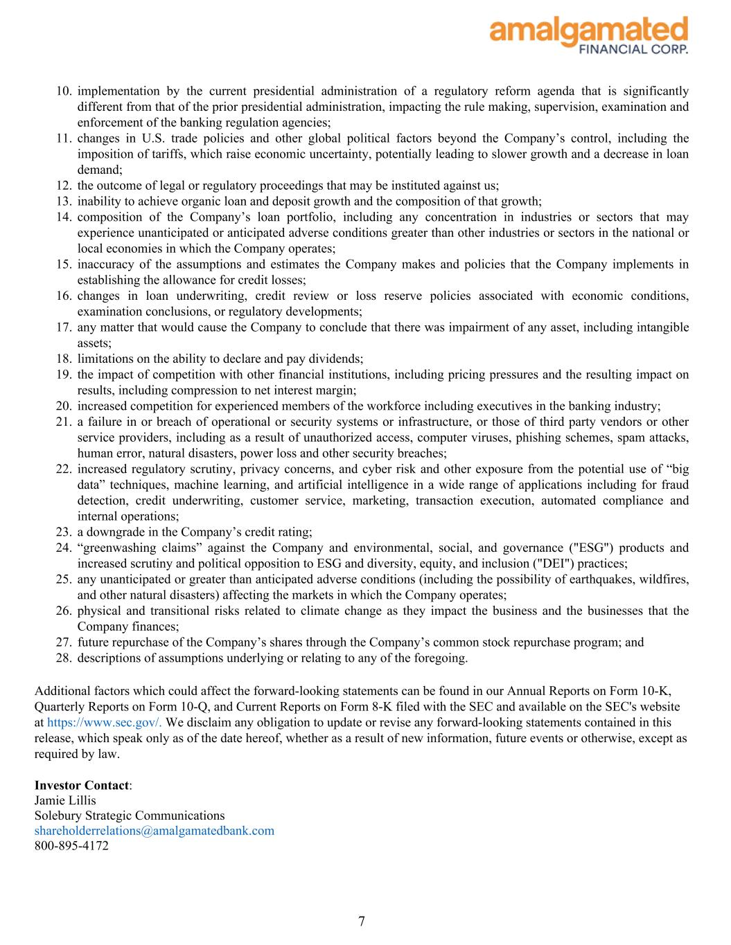
10. implementation by the current presidential administration of a regulatory reform agenda that is significantly different from that of the prior presidential administration, impacting the rule making, supervision, examination and enforcement of the banking regulation agencies; 11. changes in U.S. trade policies and other global political factors beyond the Company’s control, including the imposition of tariffs, which raise economic uncertainty, potentially leading to slower growth and a decrease in loan demand; 12. the outcome of legal or regulatory proceedings that may be instituted against us; 13. inability to achieve organic loan and deposit growth and the composition of that growth; 14. composition of the Company’s loan portfolio, including any concentration in industries or sectors that may experience unanticipated or anticipated adverse conditions greater than other industries or sectors in the national or local economies in which the Company operates; 15. inaccuracy of the assumptions and estimates the Company makes and policies that the Company implements in establishing the allowance for credit losses; 16. changes in loan underwriting, credit review or loss reserve policies associated with economic conditions, examination conclusions, or regulatory developments; 17. any matter that would cause the Company to conclude that there was impairment of any asset, including intangible assets; 18. limitations on the ability to declare and pay dividends; 19. the impact of competition with other financial institutions, including pricing pressures and the resulting impact on results, including compression to net interest margin; 20. increased competition for experienced members of the workforce including executives in the banking industry; 21. a failure in or breach of operational or security systems or infrastructure, or those of third party vendors or other service providers, including as a result of unauthorized access, computer viruses, phishing schemes, spam attacks, human error, natural disasters, power loss and other security breaches; 22. increased regulatory scrutiny, privacy concerns, and cyber risk and other exposure from the potential use of “big data” techniques, machine learning, and artificial intelligence in a wide range of applications including for fraud detection, credit underwriting, customer service, marketing, transaction execution, automated compliance and internal operations; 23. a downgrade in the Company’s credit rating; 24. “greenwashing claims” against the Company and environmental, social, and governance ("ESG") products and increased scrutiny and political opposition to ESG and diversity, equity, and inclusion ("DEI") practices; 25. any unanticipated or greater than anticipated adverse conditions (including the possibility of earthquakes, wildfires, and other natural disasters) affecting the markets in which the Company operates; 26. physical and transitional risks related to climate change as they impact the business and the businesses that the Company finances; 27. future repurchase of the Company’s shares through the Company’s common stock repurchase program; and 28. descriptions of assumptions underlying or relating to any of the foregoing. Additional factors which could affect the forward-looking statements can be found in our Annual Reports on Form 10-K, Quarterly Reports on Form 10-Q, and Current Reports on Form 8-K filed with the SEC and available on the SEC's website at https://www.sec.gov/. We disclaim any obligation to update or revise any forward-looking statements contained in this release, which speak only as of the date hereof, whether as a result of new information, future events or otherwise, except as required by law. Investor Contact: Jamie Lillis Solebury Strategic Communications shareholderrelations@amalgamatedbank.com 800-895-4172 7

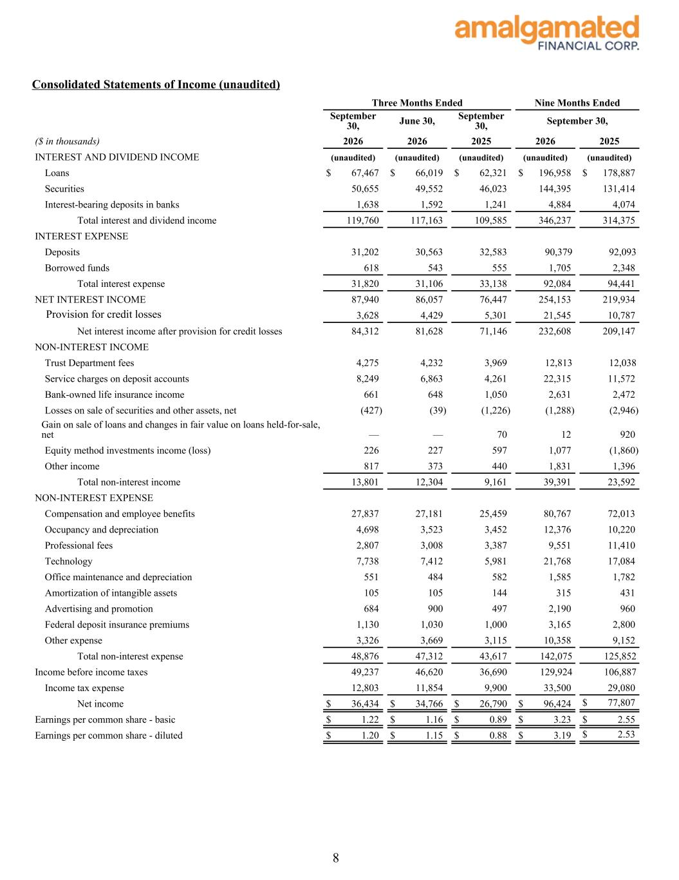
Consolidated Statements of Income (unaudited) September 30, June 30, September 30, September 30, ($ in thousands) 2026 2026 2025 2026 2025 INTEREST AND DIVIDEND INCOME (unaudited) (unaudited) (unaudited) (unaudited) (unaudited) Loans $ 67,467 $ 66,019 $ 62,321 $ 196,958 $ 178,887 Securities 50,655 49,552 46,023 144,395 131,414 Interest-bearing deposits in banks 1,638 1,592 1,241 4,884 4,074 Total interest and dividend income 119,760 117,163 109,585 346,237 314,375 INTEREST EXPENSE Deposits 31,202 30,563 32,583 90,379 92,093 Borrowed funds 618 543 555 1,705 2,348 Total interest expense 31,820 31,106 33,138 92,084 94,441 NET INTEREST INCOME 87,940 86,057 76,447 254,153 219,934 Provision for credit losses 3,628 4,429 5,301 21,545 10,787 Net interest income after provision for credit losses 84,312 81,628 71,146 232,608 209,147 NON-INTEREST INCOME Trust Department fees 4,275 4,232 3,969 12,813 12,038 Service charges on deposit accounts 8,249 6,863 4,261 22,315 11,572 Bank-owned life insurance income 661 648 1,050 2,631 2,472 Losses on sale of securities and other assets, net (427) (39) (1,226) (1,288) (2,946) Gain on sale of loans and changes in fair value on loans held-for-sale, net — — 70 12 920 Equity method investments income (loss) 226 227 597 1,077 (1,860) Other income 817 373 440 1,831 1,396 Total non-interest income 13,801 12,304 9,161 39,391 23,592 NON-INTEREST EXPENSE Compensation and employee benefits 27,837 27,181 25,459 80,767 72,013 Occupancy and depreciation 4,698 3,523 3,452 12,376 10,220 Professional fees 2,807 3,008 3,387 9,551 11,410 Technology 7,738 7,412 5,981 21,768 17,084 Office maintenance and depreciation 551 484 582 1,585 1,782 Amortization of intangible assets 105 105 144 315 431 Advertising and promotion 684 900 497 2,190 960 Federal deposit insurance premiums 1,130 1,030 1,000 3,165 2,800 Other expense 3,326 3,669 3,115 10,358 9,152 Total non-interest expense 48,876 47,312 43,617 142,075 125,852 Income before income taxes 49,237 46,620 36,690 129,924 106,887 Income tax expense 12,803 11,854 9,900 33,500 29,080 Net income $ 36,434 $ 34,766 $ 26,790 $ 96,424 $ 77,807 Earnings per common share - basic $ 1.22 $ 1.16 $ 0.89 $ 3.23 $ 2.55 Earnings per common share - diluted $ 1.20 $ 1.15 $ 0.88 $ 3.19 $ 2.53 Three Months Ended Nine Months Ended 8

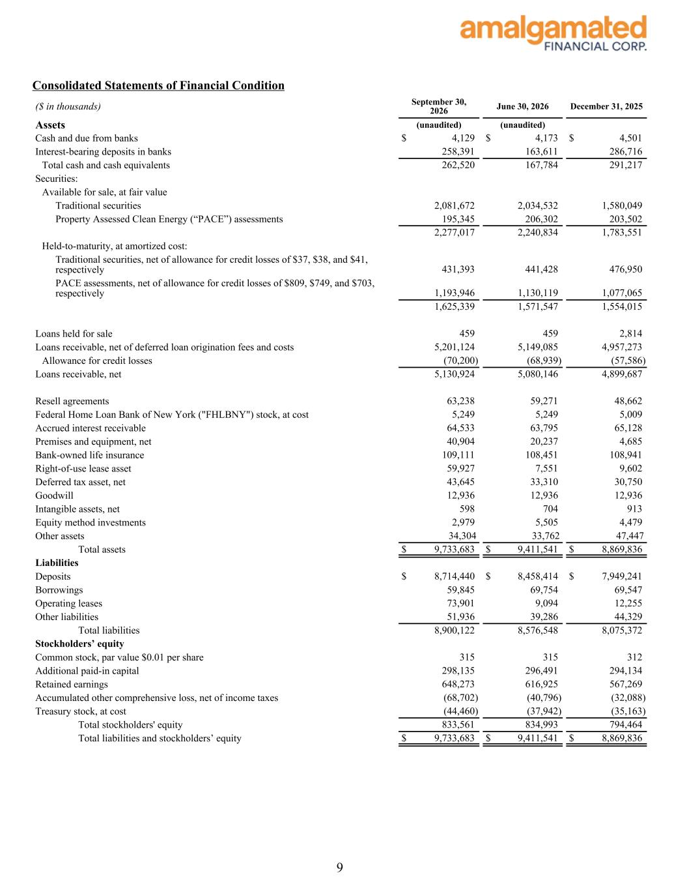
Consolidated Statements of Financial Condition ($ in thousands) September 30, 2026 June 30, 2026 December 31, 2025 Assets (unaudited) (unaudited) Cash and due from banks $ 4,129 $ 4,173 $ 4,501 Interest-bearing deposits in banks 258,391 163,611 286,716 Total cash and cash equivalents 262,520 167,784 291,217 Securities: Available for sale, at fair value Traditional securities 2,081,672 2,034,532 1,580,049 Property Assessed Clean Energy (“PACE”) assessments 195,345 206,302 203,502 2,277,017 2,240,834 1,783,551 Held-to-maturity, at amortized cost: Traditional securities, net of allowance for credit losses of $37, $38, and $41, respectively 431,393 441,428 476,950 PACE assessments, net of allowance for credit losses of $809, $749, and $703, respectively 1,193,946 1,130,119 1,077,065 1,625,339 1,571,547 1,554,015 Loans held for sale 459 459 2,814 Loans receivable, net of deferred loan origination fees and costs 5,201,124 5,149,085 4,957,273 Allowance for credit losses (70,200) (68,939) (57,586) Loans receivable, net 5,130,924 5,080,146 4,899,687 Resell agreements 63,238 59,271 48,662 Federal Home Loan Bank of New York ("FHLBNY") stock, at cost 5,249 5,249 5,009 Accrued interest receivable 64,533 63,795 65,128 Premises and equipment, net 40,904 20,237 4,685 Bank-owned life insurance 109,111 108,451 108,941 Right-of-use lease asset 59,927 7,551 9,602 Deferred tax asset, net 43,645 33,310 30,750 Goodwill 12,936 12,936 12,936 Intangible assets, net 598 704 913 Equity method investments 2,979 5,505 4,479 Other assets 34,304 33,762 47,447 Total assets $ 9,733,683 $ 9,411,541 $ 8,869,836 Liabilities Deposits $ 8,714,440 $ 8,458,414 $ 7,949,241 Borrowings 59,845 69,754 69,547 Operating leases 73,901 9,094 12,255 Other liabilities 51,936 39,286 44,329 Total liabilities 8,900,122 8,576,548 8,075,372 Stockholders’ equity Common stock, par value $0.01 per share 315 315 312 Additional paid-in capital 298,135 296,491 294,134 Retained earnings 648,273 616,925 567,269 Accumulated other comprehensive loss, net of income taxes (68,702) (40,796) (32,088) Treasury stock, at cost (44,460) (37,942) (35,163) Total stockholders' equity 833,561 834,993 794,464 Total liabilities and stockholders’ equity $ 9,733,683 $ 9,411,541 $ 8,869,836 9

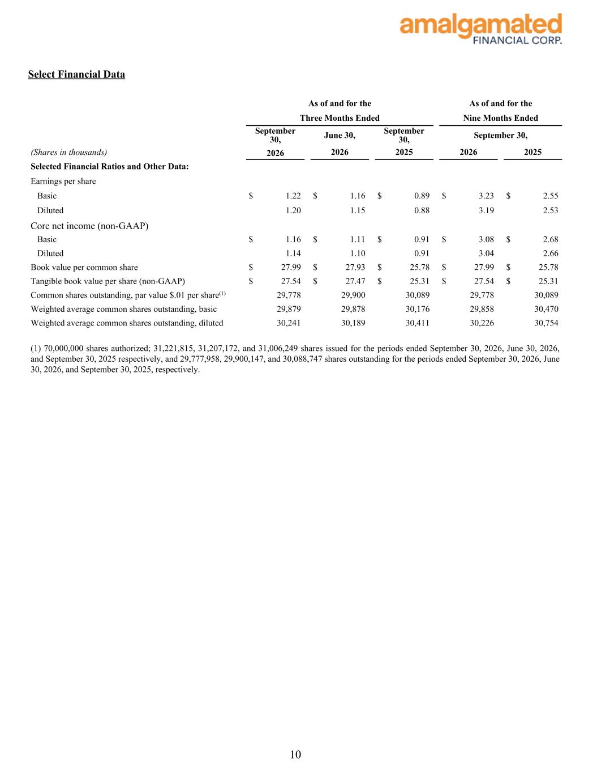
Select Financial Data As of and for the As of and for the Three Months Ended Nine Months Ended September 30, June 30, September 30, September 30, (Shares in thousands) 2026 2026 2025 2026 2025 Selected Financial Ratios and Other Data: Earnings per share Basic $ 1.22 $ 1.16 $ 0.89 $ 3.23 $ 2.55 Diluted 1.20 1.15 0.88 3.19 2.53 Core net income (non-GAAP) Basic $ 1.16 $ 1.11 $ 0.91 $ 3.08 $ 2.68 Diluted 1.14 1.10 0.91 3.04 2.66 Book value per common share $ 27.99 $ 27.93 $ 25.78 $ 27.99 $ 25.78 Tangible book value per share (non-GAAP) $ 27.54 $ 27.47 $ 25.31 $ 27.54 $ 25.31 Common shares outstanding, par value $.01 per share(1) 29,778 29,900 30,089 29,778 30,089 Weighted average common shares outstanding, basic 29,879 29,878 30,176 29,858 30,470 Weighted average common shares outstanding, diluted 30,241 30,189 30,411 30,226 30,754 (1) 70,000,000 shares authorized; 31,221,815, 31,207,172, and 31,006,249 shares issued for the periods ended September 30, 2026, June 30, 2026, and September 30, 2025 respectively, and 29,777,958, 29,900,147, and 30,088,747 shares outstanding for the periods ended September 30, 2026, June 30, 2026, and September 30, 2025, respectively. 10

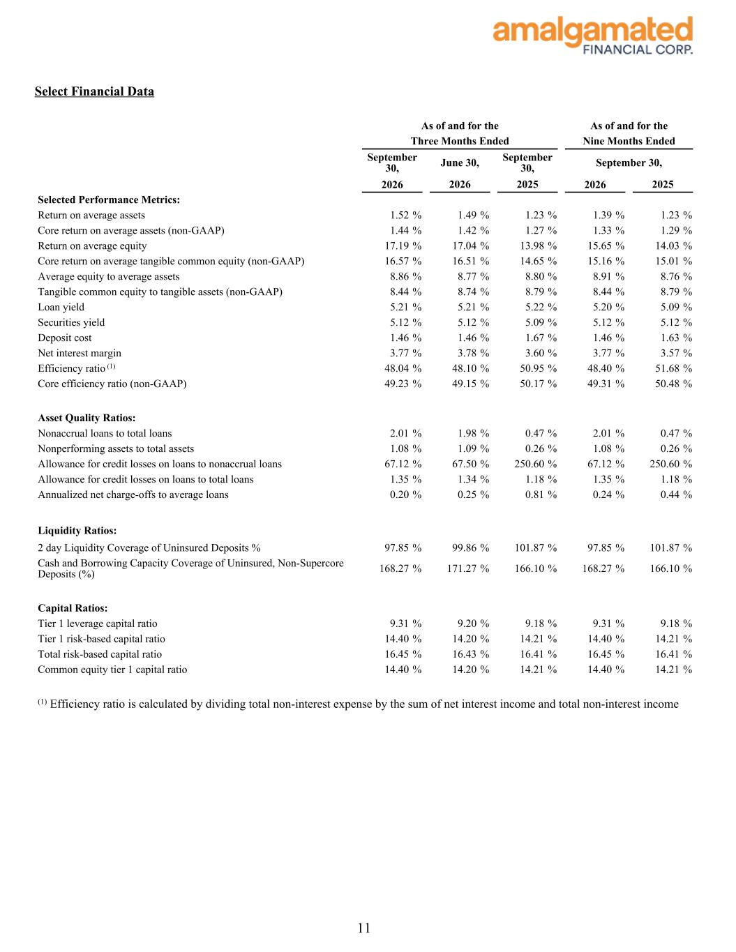
Select Financial Data As of and for the As of and for the Three Months Ended Nine Months Ended September 30, June 30, September 30, September 30, 2026 2026 2025 2026 2025 Selected Performance Metrics: Return on average assets 1.52 % 1.49 % 1.23 % 1.39 % 1.23 % Core return on average assets (non-GAAP) 1.44 % 1.42 % 1.27 % 1.33 % 1.29 % Return on average equity 17.19 % 17.04 % 13.98 % 15.65 % 14.03 % Core return on average tangible common equity (non-GAAP) 16.57 % 16.51 % 14.65 % 15.16 % 15.01 % Average equity to average assets 8.86 % 8.77 % 8.80 % 8.91 % 8.76 % Tangible common equity to tangible assets (non-GAAP) 8.44 % 8.74 % 8.79 % 8.44 % 8.79 % Loan yield 5.21 % 5.21 % 5.22 % 5.20 % 5.09 % Securities yield 5.12 % 5.12 % 5.09 % 5.12 % 5.12 % Deposit cost 1.46 % 1.46 % 1.67 % 1.46 % 1.63 % Net interest margin 3.77 % 3.78 % 3.60 % 3.77 % 3.57 % Efficiency ratio (1) 48.04 % 48.10 % 50.95 % 48.40 % 51.68 % Core efficiency ratio (non-GAAP) 49.23 % 49.15 % 50.17 % 49.31 % 50.48 % Asset Quality Ratios: Nonaccrual loans to total loans 2.01 % 1.98 % 0.47 % 2.01 % 0.47 % Nonperforming assets to total assets 1.08 % 1.09 % 0.26 % 1.08 % 0.26 % Allowance for credit losses on loans to nonaccrual loans 67.12 % 67.50 % 250.60 % 67.12 % 250.60 % Allowance for credit losses on loans to total loans 1.35 % 1.34 % 1.18 % 1.35 % 1.18 % Annualized net charge-offs to average loans 0.20 % 0.25 % 0.81 % 0.24 % 0.44 % Liquidity Ratios: 2 day Liquidity Coverage of Uninsured Deposits % 97.85 % 99.86 % 101.87 % 97.85 % 101.87 % Cash and Borrowing Capacity Coverage of Uninsured, Non-Supercore Deposits (%) 168.27 % 171.27 % 166.10 % 168.27 % 166.10 % Capital Ratios: Tier 1 leverage capital ratio 9.31 % 9.20 % 9.18 % 9.31 % 9.18 % Tier 1 risk-based capital ratio 14.40 % 14.20 % 14.21 % 14.40 % 14.21 % Total risk-based capital ratio 16.45 % 16.43 % 16.41 % 16.45 % 16.41 % Common equity tier 1 capital ratio 14.40 % 14.20 % 14.21 % 14.40 % 14.21 % (1) Efficiency ratio is calculated by dividing total non-interest expense by the sum of net interest income and total non-interest income 11

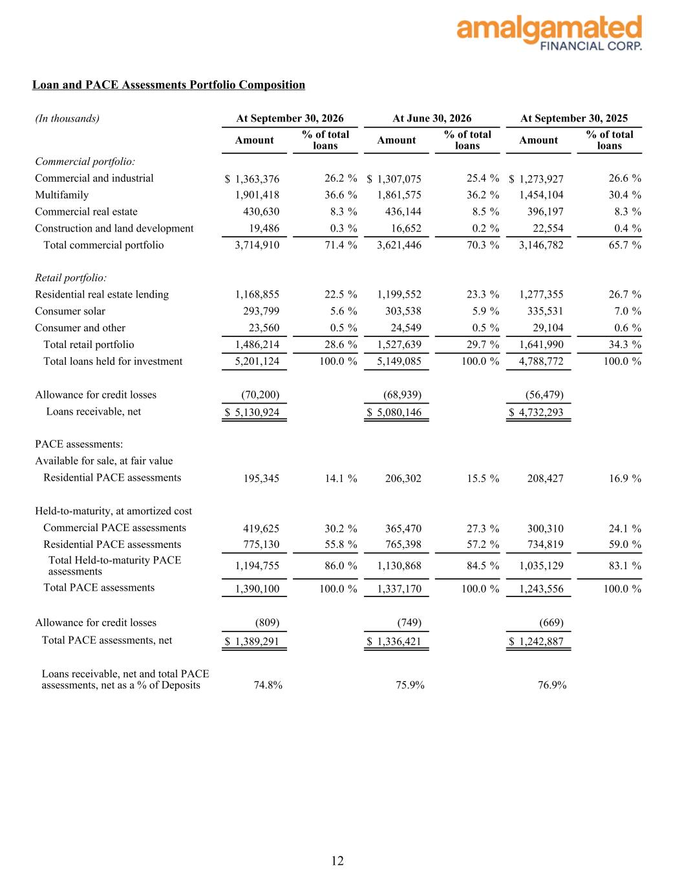
Loan and PACE Assessments Portfolio Composition (In thousands) At September 30, 2026 At June 30, 2026 At September 30, 2025 Amount % of total loans Amount % of total loans Amount % of total loans Commercial portfolio: Commercial and industrial $ 1,363,376 26.2 % $ 1,307,075 25.4 % $ 1,273,927 26.6 % Multifamily 1,901,418 36.6 % 1,861,575 36.2 % 1,454,104 30.4 % Commercial real estate 430,630 8.3 % 436,144 8.5 % 396,197 8.3 % Construction and land development 19,486 0.3 % 16,652 0.2 % 22,554 0.4 % Total commercial portfolio 3,714,910 71.4 % 3,621,446 70.3 % 3,146,782 65.7 % Retail portfolio: Residential real estate lending 1,168,855 22.5 % 1,199,552 23.3 % 1,277,355 26.7 % Consumer solar 293,799 5.6 % 303,538 5.9 % 335,531 7.0 % Consumer and other 23,560 0.5 % 24,549 0.5 % 29,104 0.6 % Total retail portfolio 1,486,214 28.6 % 1,527,639 29.7 % 1,641,990 34.3 % Total loans held for investment 5,201,124 100.0 % 5,149,085 100.0 % 4,788,772 100.0 % Allowance for credit losses (70,200) (68,939) (56,479) Loans receivable, net $ 5,130,924 $ 5,080,146 $ 4,732,293 PACE assessments: Available for sale, at fair value Residential PACE assessments 195,345 14.1 % 206,302 15.5 % 208,427 16.9 % Held-to-maturity, at amortized cost Commercial PACE assessments 419,625 30.2 % 365,470 27.3 % 300,310 24.1 % Residential PACE assessments 775,130 55.8 % 765,398 57.2 % 734,819 59.0 % Total Held-to-maturity PACE assessments 1,194,755 86.0 % 1,130,868 84.5 % 1,035,129 83.1 % Total PACE assessments 1,390,100 100.0 % 1,337,170 100.0 % 1,243,556 100.0 % Allowance for credit losses (809) (749) (669) Total PACE assessments, net $ 1,389,291 $ 1,336,421 $ 1,242,887 Loans receivable, net and total PACE assessments, net as a % of Deposits 74.8% 75.9% 76.9% 12

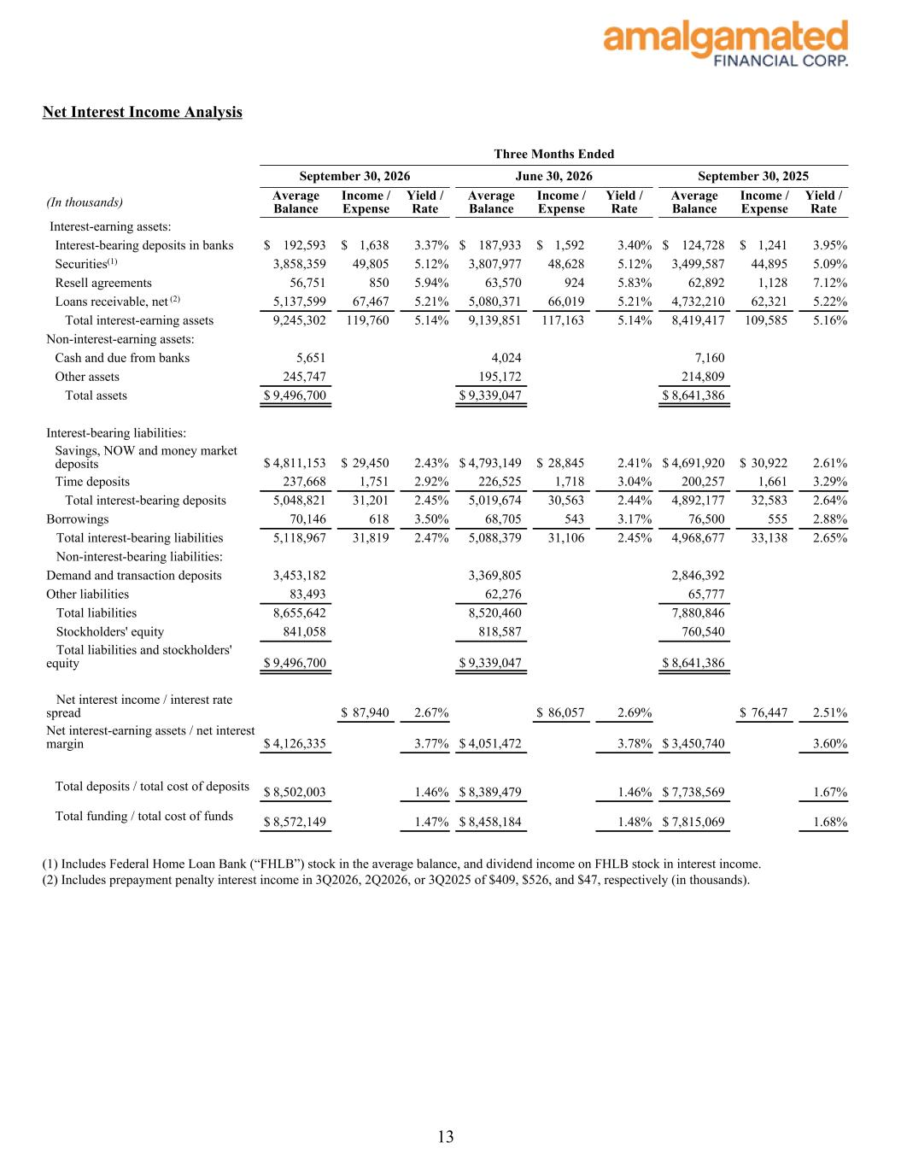
Net Interest Income Analysis Three Months Ended September 30, 2026 June 30, 2026 September 30, 2025 (In thousands) Average Balance Income / Expense Yield / Rate Average Balance Income / Expense Yield / Rate Average Balance Income / Expense Yield / Rate Interest-earning assets: Interest-bearing deposits in banks $ 192,593 $ 1,638 3.37 % $ 187,933 $ 1,592 3.40 % $ 124,728 $ 1,241 3.95 % Securities(1) 3,858,359 49,805 5.12 % 3,807,977 48,628 5.12 % 3,499,587 44,895 5.09 % Resell agreements 56,751 850 5.94 % 63,570 924 5.83 % 62,892 1,128 7.12 % Loans receivable, net (2) 5,137,599 67,467 5.21 % 5,080,371 66,019 5.21 % 4,732,210 62,321 5.22 % Total interest-earning assets 9,245,302 119,760 5.14 % 9,139,851 117,163 5.14 % 8,419,417 109,585 5.16 % Non-interest-earning assets: Cash and due from banks 5,651 4,024 7,160 Other assets 245,747 195,172 214,809 Total assets $ 9,496,700 $ 9,339,047 $ 8,641,386 Interest-bearing liabilities: Savings, NOW and money market deposits $ 4,811,153 $ 29,450 2.43 % $ 4,793,149 $ 28,845 2.41 % $ 4,691,920 $ 30,922 2.61 % Time deposits 237,668 1,751 2.92 % 226,525 1,718 3.04 % 200,257 1,661 3.29 % Total interest-bearing deposits 5,048,821 31,201 2.45 % 5,019,674 30,563 2.44 % 4,892,177 32,583 2.64 % Borrowings 70,146 618 3.50 % 68,705 543 3.17 % 76,500 555 2.88 % Total interest-bearing liabilities 5,118,967 31,819 2.47 % 5,088,379 31,106 2.45 % 4,968,677 33,138 2.65 % Non-interest-bearing liabilities: Demand and transaction deposits 3,453,182 3,369,805 2,846,392 Other liabilities 83,493 62,276 65,777 Total liabilities 8,655,642 8,520,460 7,880,846 Stockholders' equity 841,058 818,587 760,540 Total liabilities and stockholders' equity $ 9,496,700 $ 9,339,047 $ 8,641,386 Net interest income / interest rate spread $ 87,940 2.67 % $ 86,057 2.69 % $ 76,447 2.51 % Net interest-earning assets / net interest margin $ 4,126,335 3.77 % $ 4,051,472 3.78 % $ 3,450,740 3.60 % Total deposits / total cost of deposits $ 8,502,003 1.46 % $ 8,389,479 1.46 % $ 7,738,569 1.67 % Total funding / total cost of funds $ 8,572,149 1.47 % $ 8,458,184 1.48 % $ 7,815,069 1.68 % (1) Includes Federal Home Loan Bank (“FHLB”) stock in the average balance, and dividend income on FHLB stock in interest income. (2) Includes prepayment penalty interest income in 3Q2026, 2Q2026, or 3Q2025 of $409, $526, and $47, respectively (in thousands). 13

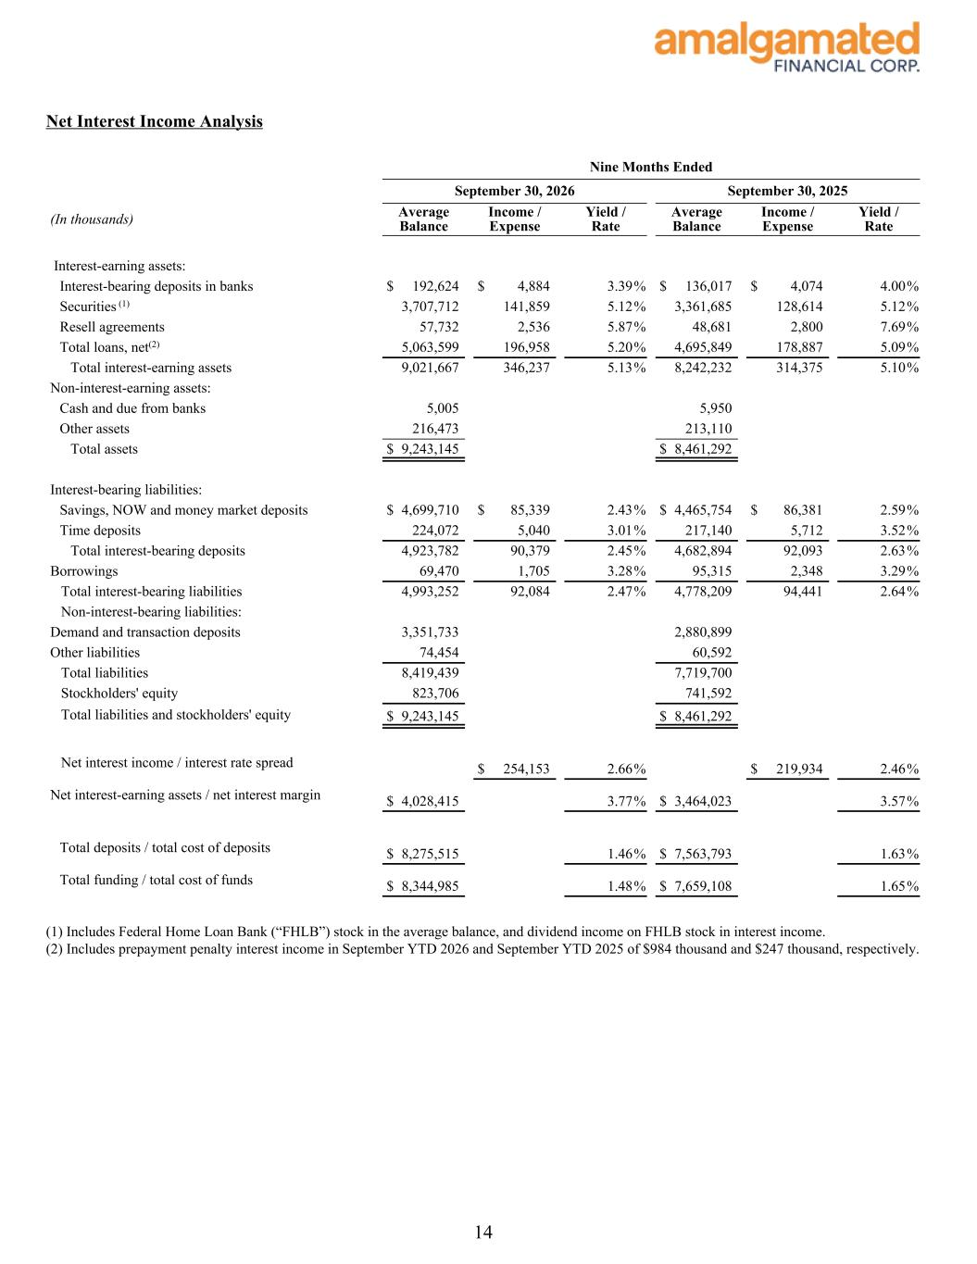
Net Interest Income Analysis Nine Months Ended September 30, 2026 September 30, 2025 (In thousands) Average Balance Income / Expense Yield / Rate Average Balance Income / Expense Yield / Rate Interest-earning assets: Interest-bearing deposits in banks $ 192,624 $ 4,884 3.39 % $ 136,017 $ 4,074 4.00 % Securities (1) 3,707,712 141,859 5.12 % 3,361,685 128,614 5.12 % Resell agreements 57,732 2,536 5.87 % 48,681 2,800 7.69 % Total loans, net(2) 5,063,599 196,958 5.20 % 4,695,849 178,887 5.09 % Total interest-earning assets 9,021,667 346,237 5.13 % 8,242,232 314,375 5.10 % Non-interest-earning assets: Cash and due from banks 5,005 5,950 Other assets 216,473 213,110 Total assets $ 9,243,145 $ 8,461,292 Interest-bearing liabilities: Savings, NOW and money market deposits $ 4,699,710 $ 85,339 2.43 % $ 4,465,754 $ 86,381 2.59 % Time deposits 224,072 5,040 3.01 % 217,140 5,712 3.52 % Total interest-bearing deposits 4,923,782 90,379 2.45 % 4,682,894 92,093 2.63 % Borrowings 69,470 1,705 3.28 % 95,315 2,348 3.29 % Total interest-bearing liabilities 4,993,252 92,084 2.47 % 4,778,209 94,441 2.64 % Non-interest-bearing liabilities: Demand and transaction deposits 3,351,733 2,880,899 Other liabilities 74,454 60,592 Total liabilities 8,419,439 7,719,700 Stockholders' equity 823,706 741,592 Total liabilities and stockholders' equity $ 9,243,145 $ 8,461,292 Net interest income / interest rate spread $ 254,153 2.66 % $ 219,934 2.46 % Net interest-earning assets / net interest margin $ 4,028,415 3.77 % $ 3,464,023 3.57 % Total deposits / total cost of deposits $ 8,275,515 1.46 % $ 7,563,793 1.63 % Total funding / total cost of funds $ 8,344,985 1.48 % $ 7,659,108 1.65 % (1) Includes Federal Home Loan Bank (“FHLB”) stock in the average balance, and dividend income on FHLB stock in interest income. (2) Includes prepayment penalty interest income in September YTD 2026 and September YTD 2025 of $984 thousand and $247 thousand, respectively. 14

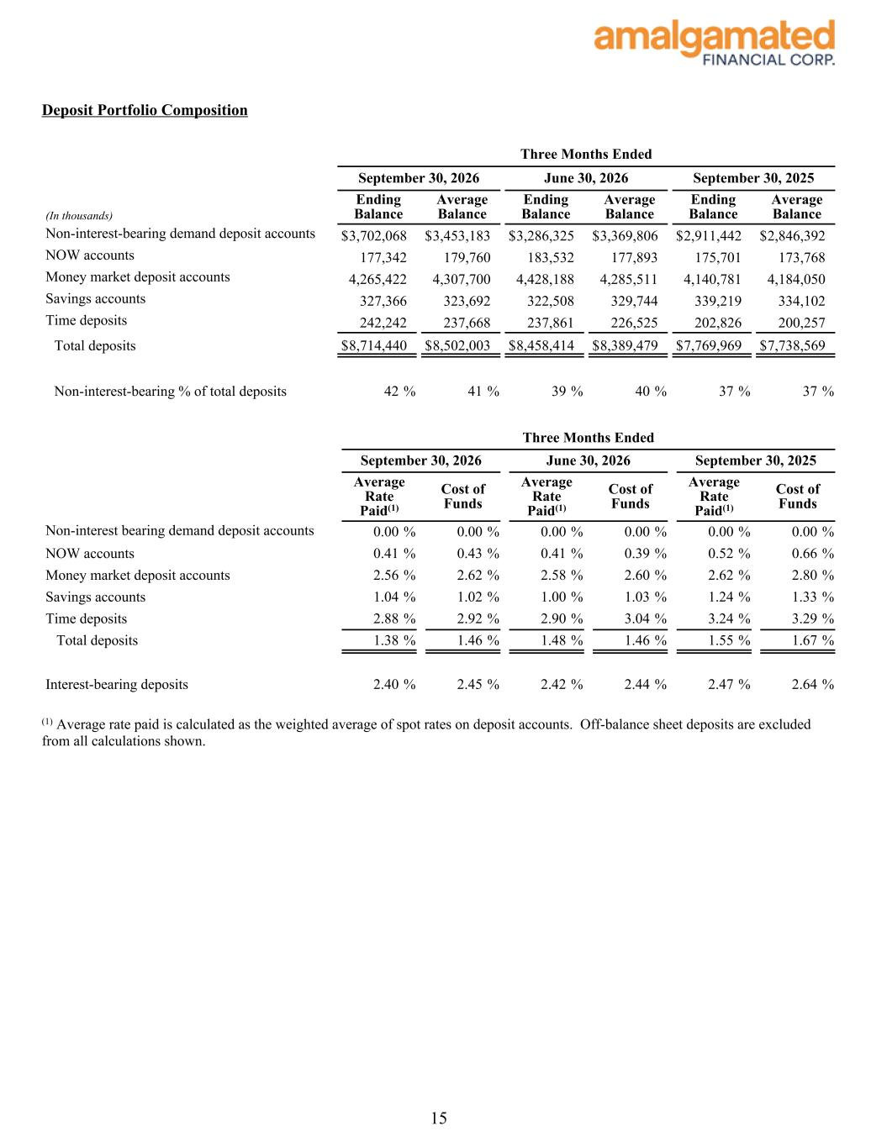
Deposit Portfolio Composition Three Months Ended September 30, 2026 June 30, 2026 September 30, 2025 (In thousands) Ending Balance Average Balance Ending Balance Average Balance Ending Balance Average Balance Non-interest-bearing demand deposit accounts $ 3,702,068 $ 3,453,183 $ 3,286,325 $ 3,369,806 $ 2,911,442 $ 2,846,392 NOW accounts 177,342 179,760 183,532 177,893 175,701 173,768 Money market deposit accounts 4,265,422 4,307,700 4,428,188 4,285,511 4,140,781 4,184,050 Savings accounts 327,366 323,692 322,508 329,744 339,219 334,102 Time deposits 242,242 237,668 237,861 226,525 202,826 200,257 Total deposits $ 8,714,440 $ 8,502,003 $ 8,458,414 $ 8,389,479 $ 7,769,969 $ 7,738,569 Non-interest-bearing % of total deposits 42 % 41 % 39 % 40 % 37 % 37 % Three Months Ended September 30, 2026 June 30, 2026 September 30, 2025 Average Rate Paid(1) Cost of Funds Average Rate Paid(1) Cost of Funds Average Rate Paid(1) Cost of Funds Non-interest bearing demand deposit accounts 0.00 % 0.00 % 0.00 % 0.00 % 0.00 % 0.00 % NOW accounts 0.41 % 0.43 % 0.41 % 0.39 % 0.52 % 0.66 % Money market deposit accounts 2.56 % 2.62 % 2.58 % 2.60 % 2.62 % 2.80 % Savings accounts 1.04 % 1.02 % 1.00 % 1.03 % 1.24 % 1.33 % Time deposits 2.88 % 2.92 % 2.90 % 3.04 % 3.24 % 3.29 % Total deposits 1.38 % 1.46 % 1.48 % 1.46 % 1.55 % 1.67 % Interest-bearing deposits 2.40 % 2.45 % 2.42 % 2.44 % 2.47 % 2.64 % (1) Average rate paid is calculated as the weighted average of spot rates on deposit accounts. Off-balance sheet deposits are excluded from all calculations shown. 15

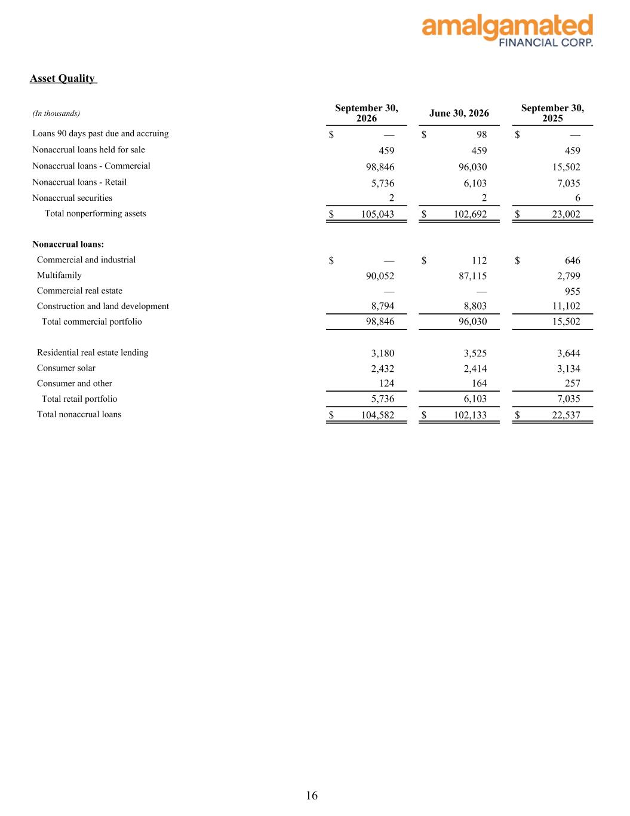
Asset Quality (In thousands) September 30, 2026 June 30, 2026 September 30, 2025 Loans 90 days past due and accruing $ — $ 98 $ — Nonaccrual loans held for sale 459 459 459 Nonaccrual loans - Commercial 98,846 96,030 15,502 Nonaccrual loans - Retail 5,736 6,103 7,035 Nonaccrual securities 2 2 6 Total nonperforming assets $ 105,043 $ 102,692 $ 23,002 Nonaccrual loans: Commercial and industrial $ — $ 112 $ 646 Multifamily 90,052 87,115 2,799 Commercial real estate — — 955 Construction and land development 8,794 8,803 11,102 Total commercial portfolio 98,846 96,030 15,502 Residential real estate lending 3,180 3,525 3,644 Consumer solar 2,432 2,414 3,134 Consumer and other 124 164 257 Total retail portfolio 5,736 6,103 7,035 Total nonaccrual loans $ 104,582 $ 102,133 $ 22,537 16

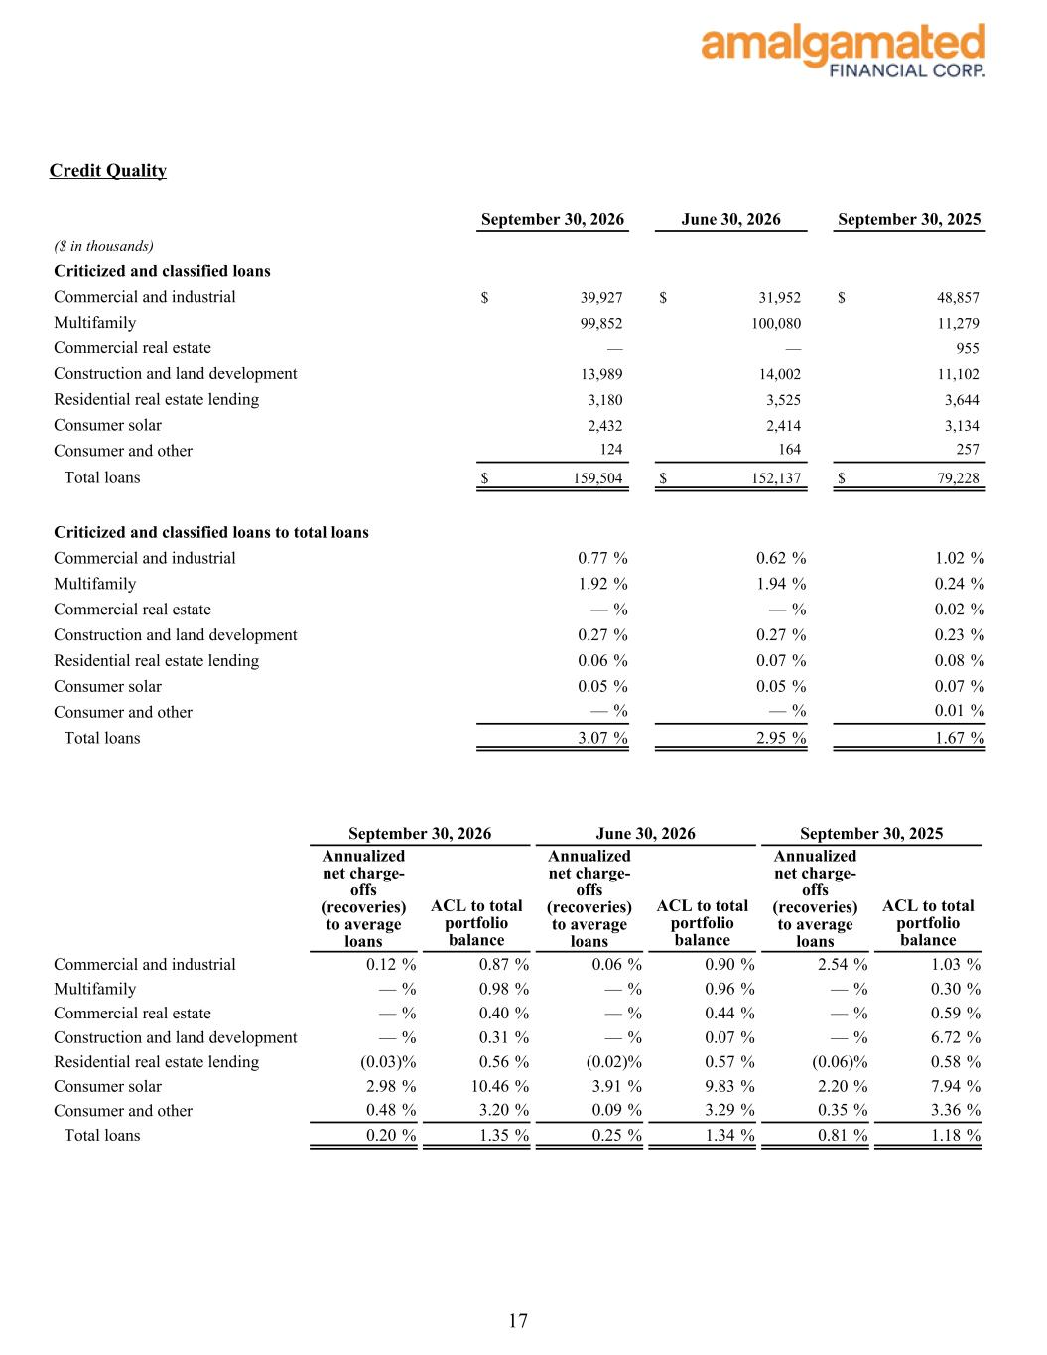
Credit Quality September 30, 2026 June 30, 2026 September 30, 2025 ($ in thousands) Criticized and classified loans Commercial and industrial $ 39,927 $ 31,952 $ 48,857 Multifamily 99,852 100,080 11,279 Commercial real estate — — 955 Construction and land development 13,989 14,002 11,102 Residential real estate lending 3,180 3,525 3,644 Consumer solar 2,432 2,414 3,134 Consumer and other 124 164 257 Total loans $ 159,504 $ 152,137 $ 79,228 Criticized and classified loans to total loans Commercial and industrial 0.77 % 0.62 % 1.02 % Multifamily 1.92 % 1.94 % 0.24 % Commercial real estate — % — % 0.02 % Construction and land development 0.27 % 0.27 % 0.23 % Residential real estate lending 0.06 % 0.07 % 0.08 % Consumer solar 0.05 % 0.05 % 0.07 % Consumer and other — % — % 0.01 % Total loans 3.07 % 2.95 % 1.67 % September 30, 2026 June 30, 2026 September 30, 2025 Annualized net charge- offs (recoveries) to average loans ACL to total portfolio balance Annualized net charge- offs (recoveries) to average loans ACL to total portfolio balance Annualized net charge- offs (recoveries) to average loans ACL to total portfolio balance Commercial and industrial 0.12 % 0.87 % 0.06 % 0.90 % 2.54 % 1.03 % Multifamily — % 0.98 % — % 0.96 % — % 0.30 % Commercial real estate — % 0.40 % — % 0.44 % — % 0.59 % Construction and land development — % 0.31 % — % 0.07 % — % 6.72 % Residential real estate lending (0.03) % 0.56 % (0.02) % 0.57 % (0.06) % 0.58 % Consumer solar 2.98 % 10.46 % 3.91 % 9.83 % 2.20 % 7.94 % Consumer and other 0.48 % 3.20 % 0.09 % 3.29 % 0.35 % 3.36 % Total loans 0.20 % 1.35 % 0.25 % 1.34 % 0.81 % 1.18 % 17

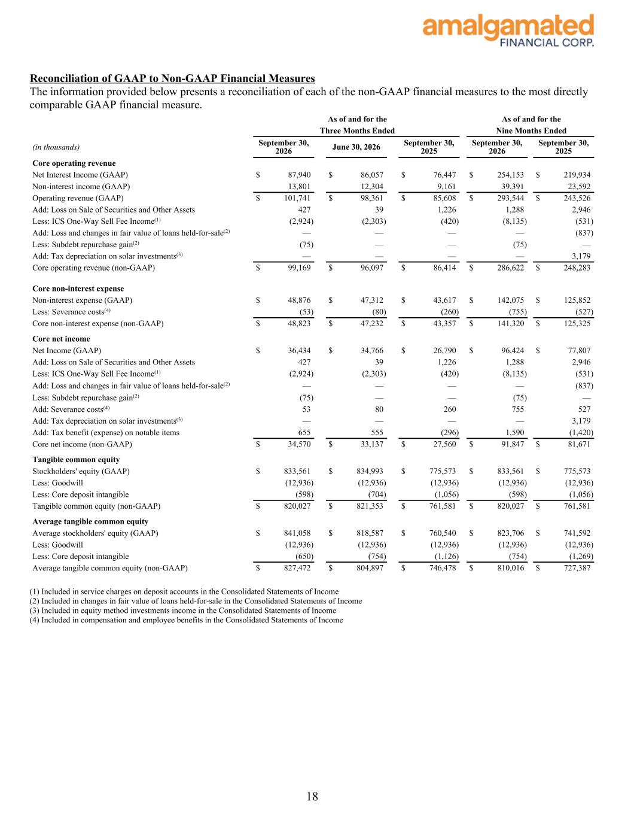
Reconciliation of GAAP to Non-GAAP Financial Measures The information provided below presents a reconciliation of each of the non-GAAP financial measures to the most directly comparable GAAP financial measure. As of and for the As of and for the Three Months Ended Nine Months Ended (in thousands) September 30, 2026 June 30, 2026 September 30, 2025 September 30, 2026 September 30, 2025 Core operating revenue Net Interest Income (GAAP) $ 87,940 $ 86,057 $ 76,447 $ 254,153 $ 219,934 Non-interest income (GAAP) 13,801 12,304 9,161 39,391 23,592 Operating revenue (GAAP) $ 101,741 $ 98,361 $ 85,608 $ 293,544 $ 243,526 Add: Loss on Sale of Securities and Other Assets 427 39 1,226 1,288 2,946 Less: ICS One-Way Sell Fee Income(1) (2,924) (2,303) (420) (8,135) (531) Add: Loss and changes in fair value of loans held-for-sale(2) — — — — (837) Less: Subdebt repurchase gain(2) (75) — — (75) — Add: Tax depreciation on solar investments(3) — — — — 3,179 Core operating revenue (non-GAAP) $ 99,169 $ 96,097 $ 86,414 $ 286,622 $ 248,283 Core non-interest expense Non-interest expense (GAAP) $ 48,876 $ 47,312 $ 43,617 $ 142,075 $ 125,852 Less: Severance costs(4) (53) (80) (260) (755) (527) Core non-interest expense (non-GAAP) $ 48,823 $ 47,232 $ 43,357 $ 141,320 $ 125,325 Core net income Net Income (GAAP) $ 36,434 $ 34,766 $ 26,790 $ 96,424 $ 77,807 Add: Loss on Sale of Securities and Other Assets 427 39 1,226 1,288 2,946 Less: ICS One-Way Sell Fee Income(1) (2,924) (2,303) (420) (8,135) (531) Add: Loss and changes in fair value of loans held-for-sale(2) — — — — (837) Less: Subdebt repurchase gain(2) (75) — — (75) — Add: Severance costs(4) 53 80 260 755 527 Add: Tax depreciation on solar investments(3) — — — — 3,179 Add: Tax benefit (expense) on notable items 655 555 (296) 1,590 (1,420) Core net income (non-GAAP) $ 34,570 $ 33,137 $ 27,560 $ 91,847 $ 81,671 Tangible common equity Stockholders' equity (GAAP) $ 833,561 $ 834,993 $ 775,573 $ 833,561 $ 775,573 Less: Goodwill (12,936) (12,936) (12,936) (12,936) (12,936) Less: Core deposit intangible (598) (704) (1,056) (598) (1,056) Tangible common equity (non-GAAP) $ 820,027 $ 821,353 $ 761,581 $ 820,027 $ 761,581 Average tangible common equity Average stockholders' equity (GAAP) $ 841,058 $ 818,587 $ 760,540 $ 823,706 $ 741,592 Less: Goodwill (12,936) (12,936) (12,936) (12,936) (12,936) Less: Core deposit intangible (650) (754) (1,126) (754) (1,269) Average tangible common equity (non-GAAP) $ 827,472 $ 804,897 $ 746,478 $ 810,016 $ 727,387 (1) Included in service charges on deposit accounts in the Consolidated Statements of Income (2) Included in changes in fair value of loans held-for-sale in the Consolidated Statements of Income (3) Included in equity method investments income in the Consolidated Statements of Income (4) Included in compensation and employee benefits in the Consolidated Statements of Income 18

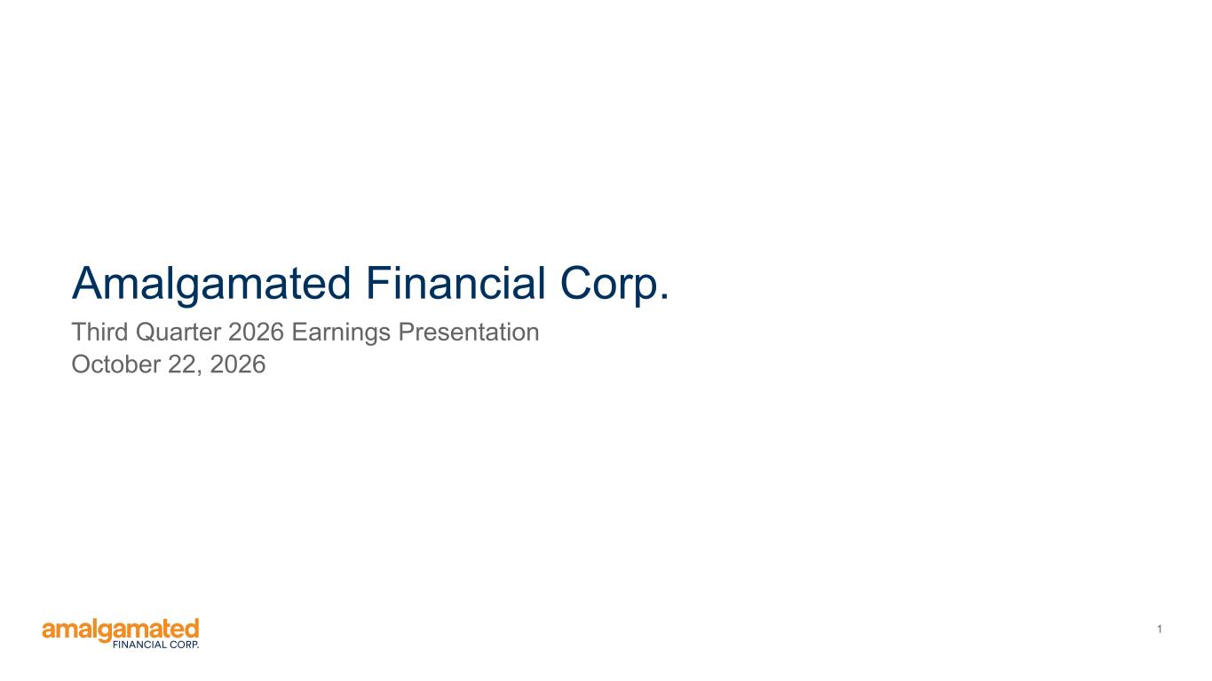
1 Amalgamated Financial Corp. Third Quarter 2026 Earnings Presentation October 22, 2026


2 Safe Harbor Statements FORWARD-LOOKING STATEMENTS Statements included in this presentation that are not historical in nature are intended to be, and are hereby identified as, forward-looking statements within the meaning of the Private Securities Litigation Reform Act, Section 21E of the Securities Exchange Act of 1934, as amended. Forward- looking statements generally can be identified through the use of forward-looking terminology such as “may,” “will,” “anticipate,” “aspire,” “should,” “would,” “believe,” “contemplate,” “expect,” “estimate,” “continue,” “in the future,” “may” and “intend,” as well as other similar words and expressions of the future. Forward-looking statements are subject to known and unknown risks, uncertainties and other factors, any or all of which could cause actual results to differ materially from the results expressed or implied by such forward-looking statements. These risks and uncertainties include, but are not limited to: 1. uncertain conditions in the banking industry and in national, regional and local economies in core markets, which may have an adverse impact on business, operations and financial performance; 2. deterioration in the financial condition of borrowers, as well as deterioration in the reputational profile of borrowers, resulting in significant increases in credit losses and provisions for those losses; 3. deposit outflows and subsequent declines in liquidity caused by factors that could include lack of confidence in the banking system, a deterioration in market conditions or the financial condition of depositors; 4. changes in deposits, including an increase in uninsured deposits; 5. ability to maintain sufficient liquidity to meet deposit and debt obligations as they come due, which may require that the Company sell investment securities at a loss, negatively impacting net income, earnings and capital; 6. unfavorable conditions in the capital markets, which may cause declines in stock price and the value of investments; 7. negative economic and political conditions that adversely affect the general economy, housing prices, the real estate market, the job market, consumer confidence, the financial condition of borrowers and consumer spending habits, which may affect, among other things, the level of non- performing assets, charge-offs and provision expense; 8. fluctuations or unanticipated changes in the interest rate environment including changes in net interest margin or changes in the yield curve that affect investments, loans or deposits; 9. the general decline in the real estate and lending markets, particularly in commercial real estate in the Company’s market areas, and the effects of the enactment of or changes to rent-control and other similar regulations on multi-family housing; 10. implementation by the current presidential administration of a regulatory reform agenda that is significantly different from that of the prior presidential administration, impacting the rule making, supervision, examination and enforcement of the banking regulation agencies; 11. changes in U.S. trade policies and other global political factors beyond the Company’s control, including the imposition of tariffs, which raise economic uncertainty, potentially leading to slower growth and a decrease in loan demand; 12. the outcome of legal or regulatory proceedings that may be instituted against us; 13. inability to achieve organic loan and deposit growth and the composition of that growth; 14. composition of the Company’s loan portfolio, including any concentration in industries or sectors that may experience unanticipated or anticipated adverse conditions greater than other industries or sectors in the national or local economies in which the Company operates; 15. inaccuracy of the assumptions and estimates the Company makes and policies that the Company implements in establishing the allowance for credit losses; 16. changes in loan underwriting, credit review or loss reserve policies associated with economic conditions, examination conclusions, or regulatory developments; 17. any matter that would cause the Company to conclude that there was impairment of any asset, including intangible assets; 18. limitations on the ability to declare and pay dividends; 19. the impact of competition with other financial institutions, including pricing pressures and the resulting impact on results, including as a result of compression to net interest margin; 20. increased competition for experienced members of the workforce including executives in the banking industry; 21. a failure in or breach of operational or security systems or infrastructure, or those of third party vendors or other service providers, including as a result of unauthorized access, computer viruses, phishing schemes, spam attacks, human error, natural disasters, power loss and other security breaches; 22. increased regulatory scrutiny, privacy concerns, and cyber risk and other exposure from the potential use of “big data” techniques, machine learning, and artificial intelligence in a wide range of applications including for fraud detection, credit underwriting, customer service, marketing, transaction execution, automated compliance and internal operations; 23. a downgrade in the Company’s credit rating; 24. “greenwashing claims” against the Company and environmental, social, and governance ("ESG") products and increased scrutiny and political opposition to ESG and diversity, equity, and inclusion ("DEI") practices; 25. any unanticipated or greater than anticipated adverse conditions (including the possibility of earthquakes, wildfires, and other natural disasters) affecting the markets in which the Company operates; 26. physical and transitional risks related to climate change as they impact the business and the businesses that the Company finances; 27. future repurchase of the Company’s shares through the Company’s common stock repurchase program; and 28. descriptions of assumptions underlying or relating to any of the foregoing. Additional factors which could affect the forward-looking statements can be found in the Company’s Annual Reports on Form 10-K, Quarterly Reports on Form 10-Q, and Current Reports on Form 8-K filed with the SEC and available on the SEC's website at https://www.sec.gov/. The Company disclaims any obligation to update or revise any forward-looking statements contained in this release, which speak only as of the date hereof, whether as a result of new information, future events or otherwise, except as required by law. NON-GAAP FINANCIAL MEASURES This presentation contains certain non-GAAP financial measures including, without limitation, “Core Operating Revenue,” “Core Non-interest Expense,” “Tangible Common Equity,” “Average Tangible Common Equity,” “Core Efficiency Ratio,” “Core Net Income,” “Core ROAA,” and “Core ROATCE.” We believe these non-GAAP financial measures provide useful information to management and investors that is supplementary to our financial condition, results of operations and cash flows computed in accordance with GAAP. Specifically, we believe these non-GAAP financial measures (a) allow management and investors to better assess our performance by removing volatility that is associated with discrete items that are unrelated to our core business, and (b) enable a more complete understanding of factors and trends affecting our business. Non-GAAP financial measures, however, have inherent limitations, are not required to be uniformly applied, and are not audited. Accordingly, these non-GAAP financial measures should not be considered as substitutes for GAAP financial measures, and we strongly encourage investors to review the GAAP financial measures included in this presentation and not to place undue reliance on any single financial measure. In addition, because non-GAAP financial measures are not standardized, it may not be possible to compare the non-GAAP financial measures presented in this presentation with other companies’ non-GAAP financial measures having the same or similar names. As such, you should not view these disclosures as a substitute for results determined in accordance with GAAP, and they are not necessarily comparable to non-GAAP financial measures that other companies use. Reconciliations of non-GAAP financial disclosures to what we believe to be the most directly comparable GAAP measures found in this presentation are set forth in the final pages of this presentation and also may be viewed on the bank’s website, amalgamatedbank.com. You should assume that all numbers presented are unaudited unless otherwise noted.

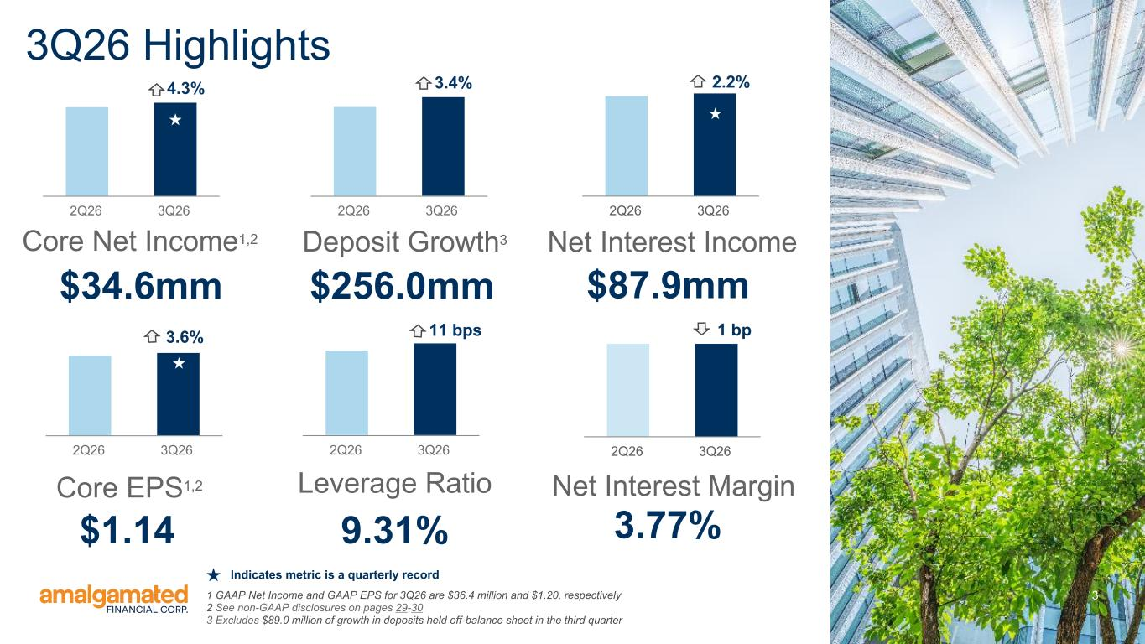
3 $34.6mm Core Net Income1,2 $1.14 Core EPS1,2 $256.0mm Deposit Growth3 9.31% Leverage Ratio $87.9mm Net Interest Income 3.77% Net Interest Margin 3Q26 Highlights 2Q26 3Q26 2Q26 3Q26 3.4% 2Q26 3Q262Q26 3Q26 2Q26 3Q26 4.3% 2Q26 3Q26 1 bp11 bps 2.2% 1 GAAP Net Income and GAAP EPS for 3Q26 are $36.4 million and $1.20, respectively 2 See non-GAAP disclosures on pages 29-30 3 Excludes $89.0 million of growth in deposits held off-balance sheet in the third quarter 3.6% Indicates metric is a quarterly record

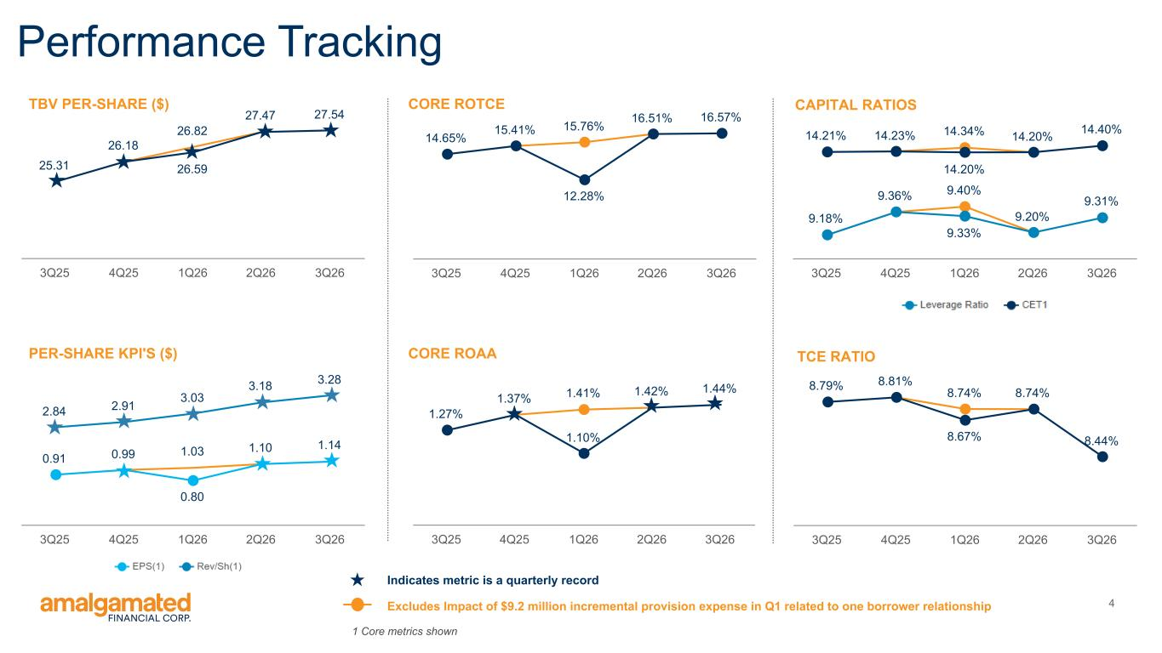
4 1.41% 1.42% 1.27% 1.37% 1.10% 1.44% 3Q25 4Q25 1Q26 2Q26 3Q26 9.40% 9.18% 9.36% 9.33% 9.20% 9.31% 14.34%14.21% 14.23% 14.20% 14.20% 14.40% 3Q25 4Q25 1Q26 2Q26 3Q26 26.82 25.31 26.18 26.59 27.47 27.54 3Q25 4Q25 1Q26 2Q26 3Q26 15.76% 16.51% 14.65% 15.41% 12.28% 16.57% 3Q25 4Q25 1Q26 2Q26 3Q26 CORE ROAAPER-SHARE KPI'S ($) TBV PER-SHARE ($) CORE ROTCE Performance Tracking 1 Core metrics shown 1.030.91 0.99 0.80 1.10 1.14 2.84 2.91 3.03 3.18 3.28 3Q25 4Q25 1Q26 2Q26 3Q26 CAPITAL RATIOS 8.74%8.79% 8.81% 8.67% 8.74% 8.44% 3Q25 4Q25 1Q26 2Q26 3Q26 TCE RATIO Excludes Impact of $9.2 million incremental provision expense in Q1 related to one borrower relationship Indicates metric is a quarterly record

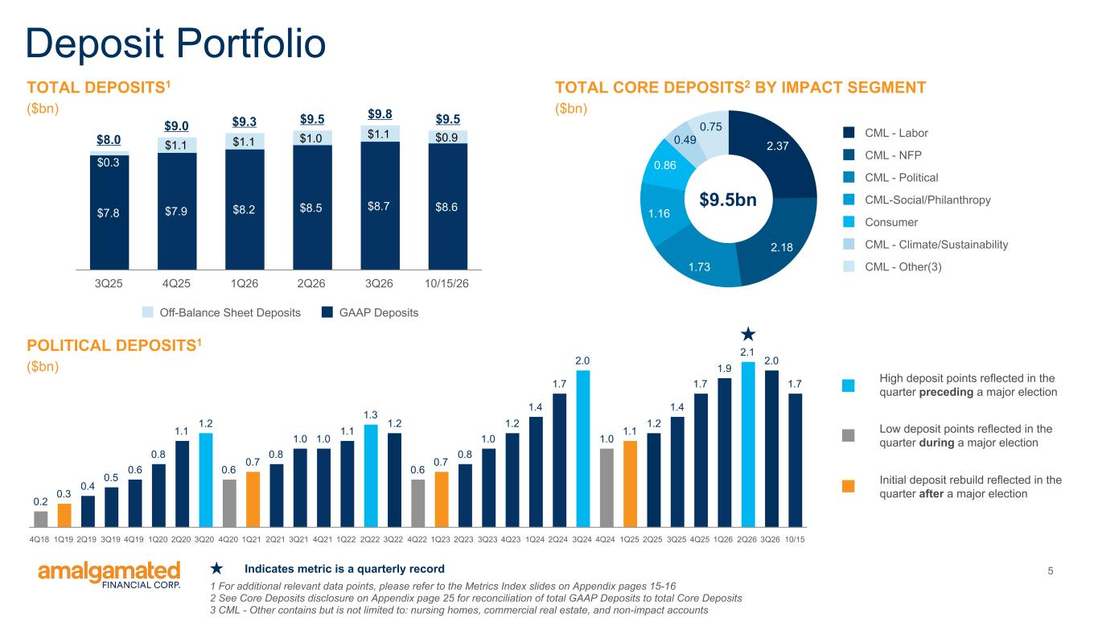
5 TOTAL DEPOSITS1 ($bn) Deposit Portfolio $8.0 $9.0 $9.3 $9.5 $9.8 $9.5 $7.8 $7.9 $8.2 $8.5 $8.7 $8.6 $0.3 $1.1 $1.1 $1.0 $1.1 $0.9 Off-Balance Sheet Deposits GAAP Deposits 3Q25 4Q25 1Q26 2Q26 3Q26 10/15/26 2.37 2.18 1.73 1.16 0.86 0.49 0.75 CML - Labor CML - NFP CML - Political CML-Social/Philanthropy Consumer CML - Climate/Sustainability CML - Other(3) 1 For additional relevant data points, please refer to the Metrics Index slides on Appendix pages 15-16 2 See Core Deposits disclosure on Appendix page 25 for reconciliation of total GAAP Deposits to total Core Deposits 3 CML - Other contains but is not limited to: nursing homes, commercial real estate, and non-impact accounts TOTAL CORE DEPOSITS2 BY IMPACT SEGMENT ($bn) POLITICAL DEPOSITS1 ($bn) 0.2 0.3 0.4 0.5 0.6 0.8 1.1 1.2 0.6 0.7 0.8 1.0 1.0 1.1 1.3 1.2 0.6 0.7 0.8 1.0 1.2 1.4 1.7 2.0 1.0 1.1 1.2 1.4 1.7 1.9 2.1 2.0 1.7 4Q18 1Q19 2Q19 3Q19 4Q19 1Q20 2Q20 3Q20 4Q20 1Q21 2Q21 3Q21 4Q21 1Q22 2Q22 3Q22 4Q22 1Q23 2Q23 3Q23 4Q23 1Q24 2Q24 3Q24 4Q24 1Q25 2Q25 3Q25 4Q25 1Q26 2Q26 3Q26 10/15 $9.5bn High deposit points reflected in the quarter preceding a major election Low deposit points reflected in the quarter during a major election Initial deposit rebuild reflected in the quarter after a major election Indicates metric is a quarterly record

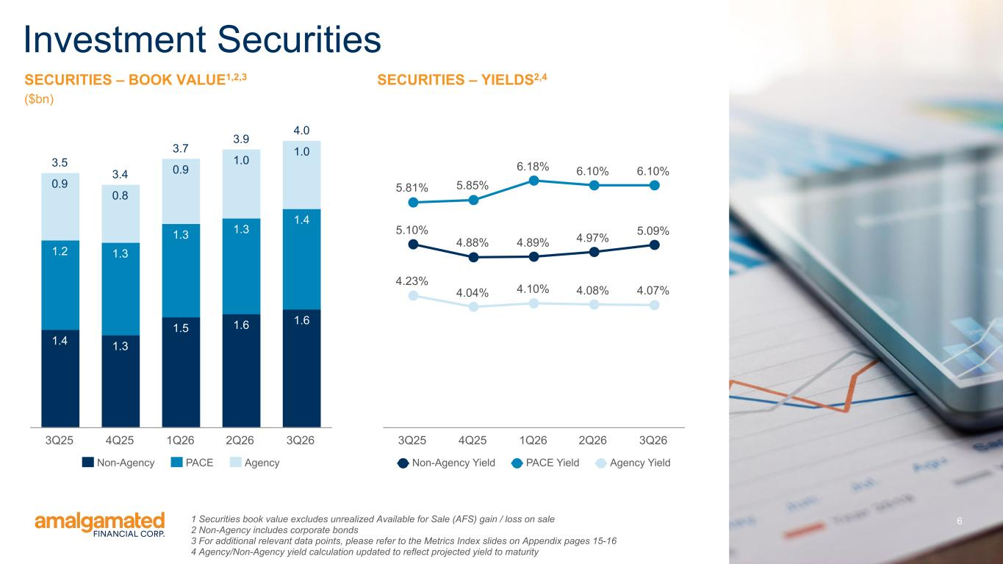
6 SECURITIES – BOOK VALUE1,2,3 ($bn) Investment Securities 3.5 3.4 3.7 3.9 4.0 1.4 1.3 1.5 1.6 1.6 1.2 1.3 1.3 1.3 1.4 0.9 0.8 0.9 1.0 1.0 Non-Agency PACE Agency 3Q25 4Q25 1Q26 2Q26 3Q26 1 Securities book value excludes unrealized Available for Sale (AFS) gain / loss on sale 2 Non-Agency includes corporate bonds 3 For additional relevant data points, please refer to the Metrics Index slides on Appendix pages 15-16 4 Agency/Non-Agency yield calculation updated to reflect projected yield to maturity SECURITIES – YIELDS2,4 5.10% 4.88% 4.89% 4.97% 5.09% 5.81% 5.85% 6.18% 6.10% 6.10% 4.23% 4.04% 4.10% 4.08% 4.07% Non-Agency Yield PACE Yield Agency Yield 3Q25 4Q25 1Q26 2Q26 3Q26

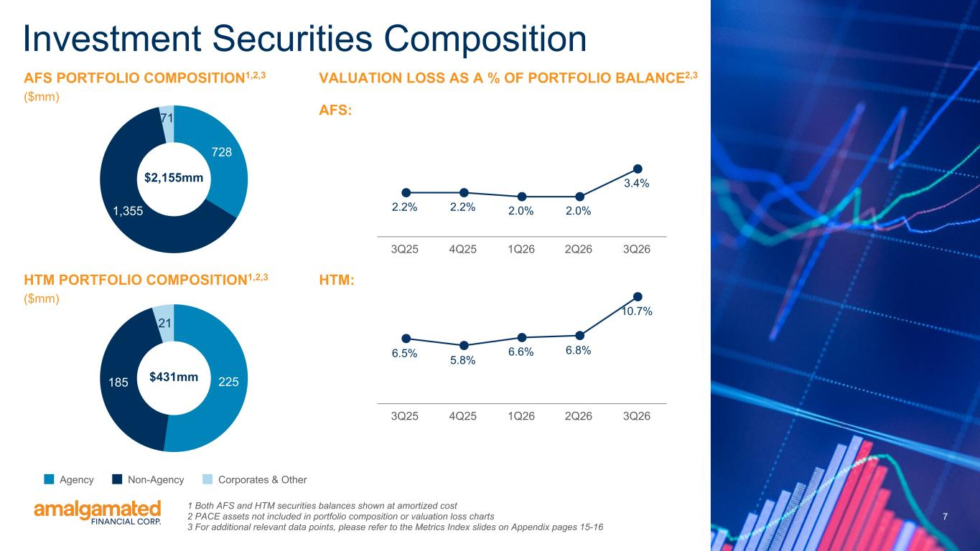
7 7 728 1,355 71 Investment Securities Composition HTM PORTFOLIO COMPOSITION1,2,3 ($mm) 225185 21 Agency Non-Agency Corporates & Other $2,155mm $431mm VALUATION LOSS AS A % OF PORTFOLIO BALANCE2,3 AFS: AFS PORTFOLIO COMPOSITION1,2,3 ($mm) 1 Both AFS and HTM securities balances shown at amortized cost 2 PACE assets not included in portfolio composition or valuation loss charts 3 For additional relevant data points, please refer to the Metrics Index slides on Appendix pages 15-16 2.2% 2.2% 2.0% 2.0% 3.4% 3Q25 4Q25 1Q26 2Q26 3Q26 6.5% 5.8% 6.6% 6.8% 10.7% 3Q25 4Q25 1Q26 2Q26 3Q26 HTM:

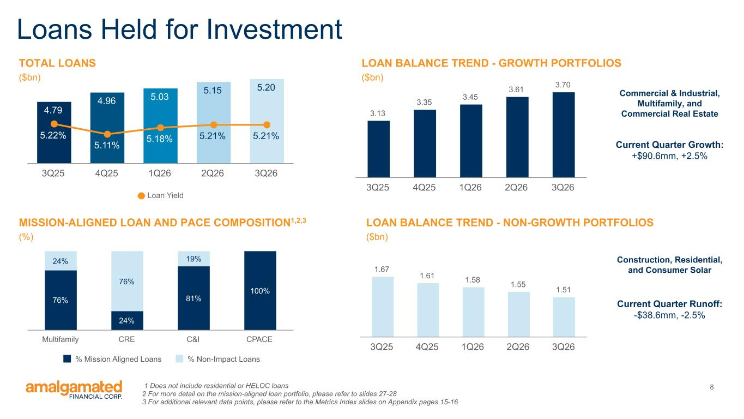
8 Loans Held for Investment TOTAL LOANS ($bn) 4.79 4.96 5.03 5.15 5.20 5.22% 5.11% 5.18% 5.21% 5.21% Loan Yield 3Q25 4Q25 1Q26 2Q26 3Q26 3.13 3.35 3.45 3.61 3.70 3Q25 4Q25 1Q26 2Q26 3Q26 LOAN BALANCE TREND - GROWTH PORTFOLIOS ($bn) 76% 24% 81% 100% 24% 76% 19% % Mission Aligned Loans % Non-Impact Loans Multifamily CRE C&I CPACE MISSION-ALIGNED LOAN AND PACE COMPOSITION1,2,3 (%) 1 Does not include residential or HELOC loans 2 For more detail on the mission-aligned loan portfolio, please refer to slides 27-28 3 For additional relevant data points, please refer to the Metrics Index slides on Appendix pages 15-16 1.67 1.61 1.58 1.55 1.51 3Q25 4Q25 1Q26 2Q26 3Q26 LOAN BALANCE TREND - NON-GROWTH PORTFOLIOS ($bn) Current Quarter Growth: +$90.6mm, +2.5% Current Quarter Runoff: -$38.6mm, -2.5% Commercial & Industrial, Multifamily, and Commercial Real Estate Construction, Residential, and Consumer Solar

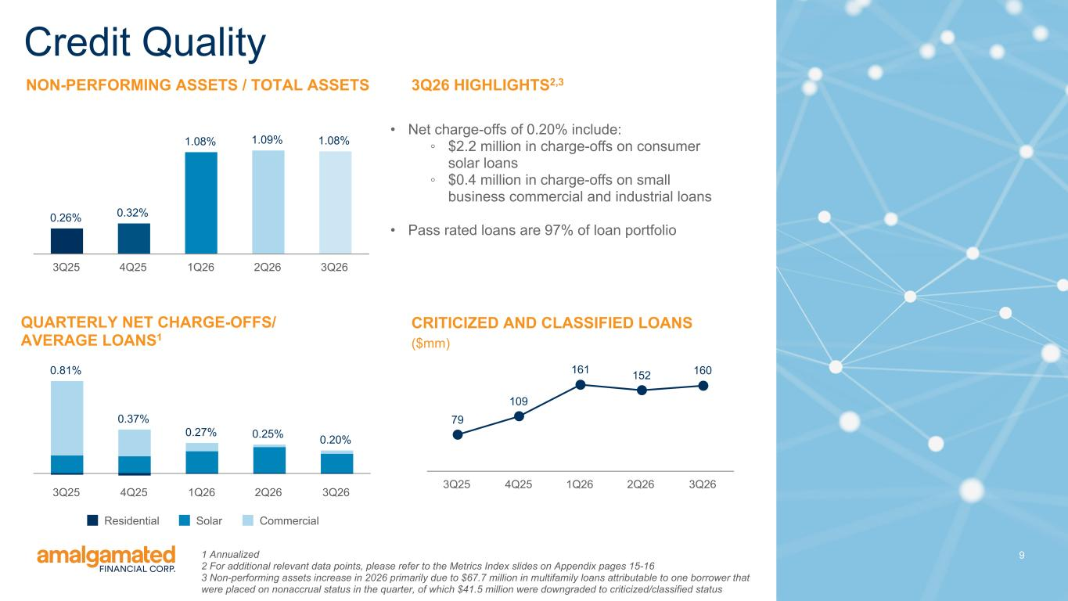
9 NON-PERFORMING ASSETS / TOTAL ASSETS Credit Quality QUARTERLY NET CHARGE-OFFS/ AVERAGE LOANS1 3Q26 HIGHLIGHTS2,3 • Net charge-offs of 0.20% include: ◦ $2.2 million in charge-offs on consumer solar loans ◦ $0.4 million in charge-offs on small business commercial and industrial loans • Pass rated loans are 97% of loan portfolio CRITICIZED AND CLASSIFIED LOANS ($mm) 0.26% 0.32% 1.08% 1.09% 1.08% 3Q25 4Q25 1Q26 2Q26 3Q26 0.81% 0.37% 0.27% 0.25% 0.20% Residential Solar Commercial 3Q25 4Q25 1Q26 2Q26 3Q26 79 109 161 152 160 3Q25 4Q25 1Q26 2Q26 3Q26 1 Annualized 2 For additional relevant data points, please refer to the Metrics Index slides on Appendix pages 15-16 3 Non-performing assets increase in 2026 primarily due to $67.7 million in multifamily loans attributable to one borrower that were placed on nonaccrual status in the quarter, of which $41.5 million were downgraded to criticized/classified status

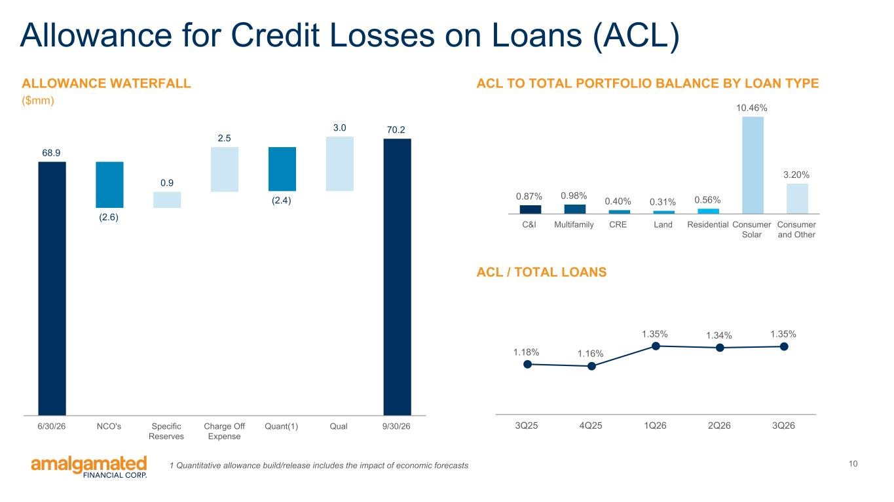
10 Allowance for Credit Losses on Loans (ACL) ACL / TOTAL LOANS 1.18% 1.16% 1.35% 1.34% 1.35% 3Q25 4Q25 1Q26 2Q26 3Q26 68.9 (2.6) 0.9 2.5 (2.4) 3.0 70.2 6/30/26 NCO's Specific Reserves Charge Off Expense Quant(1) Qual 9/30/26 ALLOWANCE WATERFALL ($mm) 0.87% 0.98% 0.40% 0.31% 0.56% 10.46% 3.20% C&I Multifamily CRE Land Residential Consumer Solar Consumer and Other ACL TO TOTAL PORTFOLIO BALANCE BY LOAN TYPE 1 Quantitative allowance build/release includes the impact of economic forecasts

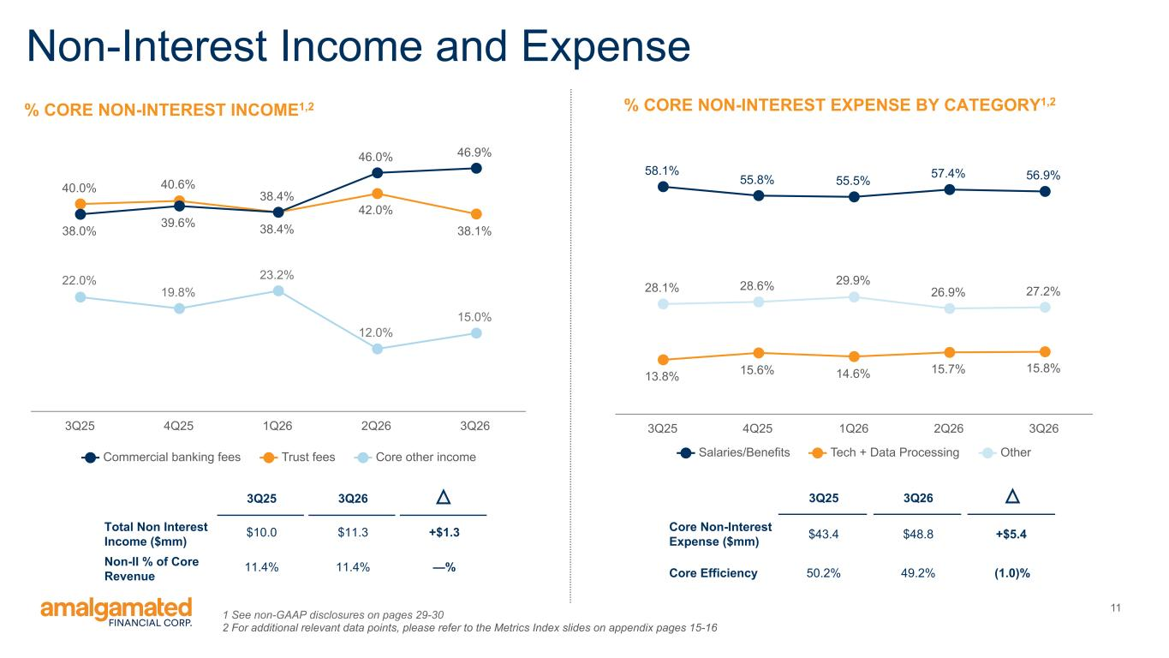
11 Non-Interest Income and Expense 22.0% 19.8% 23.2% 12.0% 15.0% 40.0% 40.6% 38.4% 42.0% 38.1%38.0% 39.6% 38.4% 46.0% 46.9% Commercial banking fees Trust fees Core other income 3Q25 4Q25 1Q26 2Q26 3Q26 % CORE NON-INTEREST INCOME1,2 1 See non-GAAP disclosures on pages 29-30 2 For additional relevant data points, please refer to the Metrics Index slides on appendix pages 15-16 58.1% 55.8% 55.5% 57.4% 56.9% 13.8% 15.6% 14.6% 15.7% 15.8% 28.1% 28.6% 29.9% 26.9% 27.2% Salaries/Benefits Tech + Data Processing Other 3Q25 4Q25 1Q26 2Q26 3Q26 % CORE NON-INTEREST EXPENSE BY CATEGORY1,2 3Q25 3Q26 Core Non-Interest Expense ($mm) $43.4 $48.8 +$5.4 Core Efficiency 50.2% 49.2% (1.0)% 3Q25 3Q26 Total Non Interest Income ($mm) $10.0 $11.3 +$1.3 Non-II % of Core Revenue 11.4% 11.4% —%

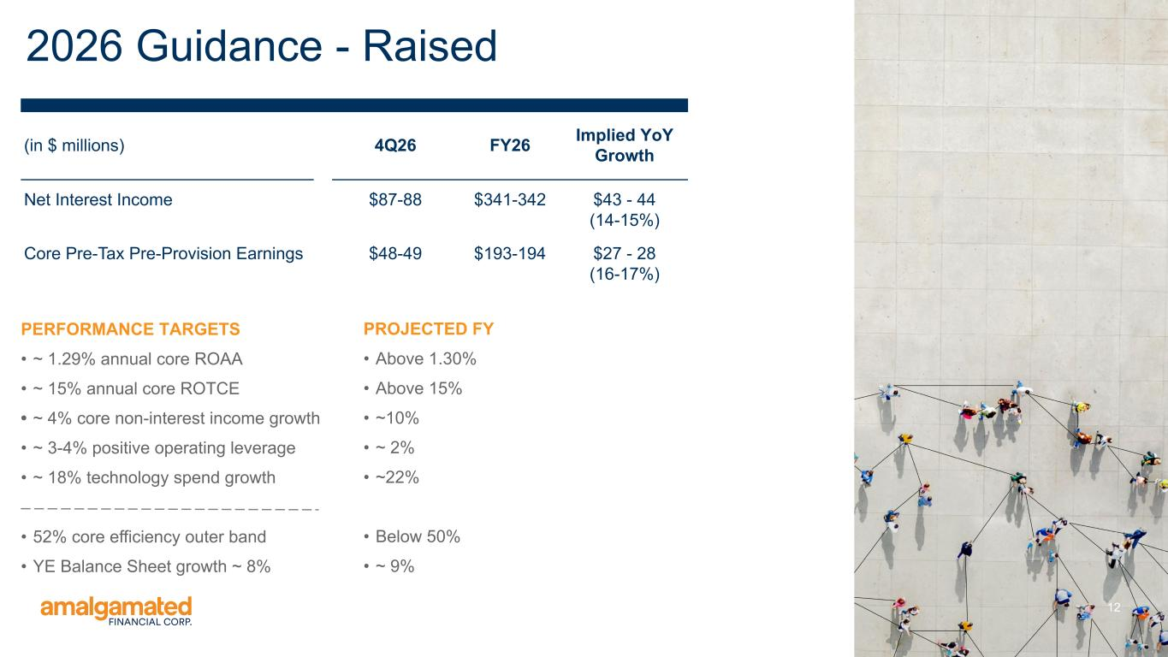
12 2026 Guidance - Raised PERFORMANCE TARGETS • ~ 1.29% annual core ROAA • ~ 15% annual core ROTCE • ~ 4% core non-interest income growth • ~ 3-4% positive operating leverage • ~ 18% technology spend growth • 52% core efficiency outer band • YE Balance Sheet growth ~ 8% (in $ millions) 4Q26 FY26 Implied YoY Growth Net Interest Income $87-88 $341-342 $43 - 44 (14-15%) Core Pre-Tax Pre-Provision Earnings $48-49 $193-194 $27 - 28 (16-17%) PROJECTED FY • Above 1.30% • Above 15% • ~10% • ~ 2% • ~22% • Below 50% • ~ 9%

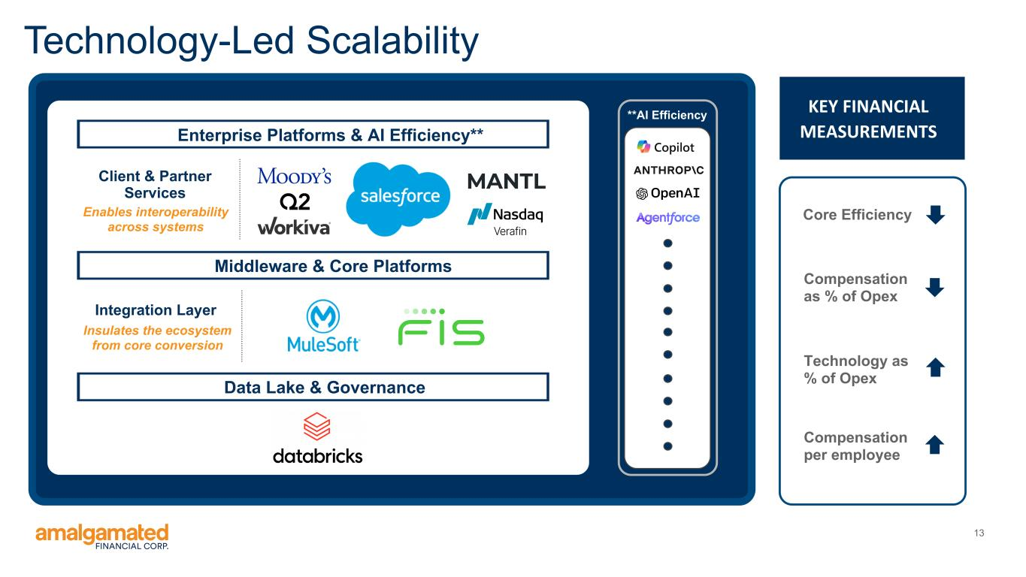
13 Enterprise Platforms & AI Efficiency** Middleware & Core Platforms Integration Layer Data Lake & Governance Technology-Led Scalability **AI Efficiency Insulates the ecosystem from core conversion Core Efficiency Compensation as % of Opex Technology as % of Opex Compensation per employee KEY FINANCIAL MEASUREMENTS Client & Partner Services Enables interoperability across systems

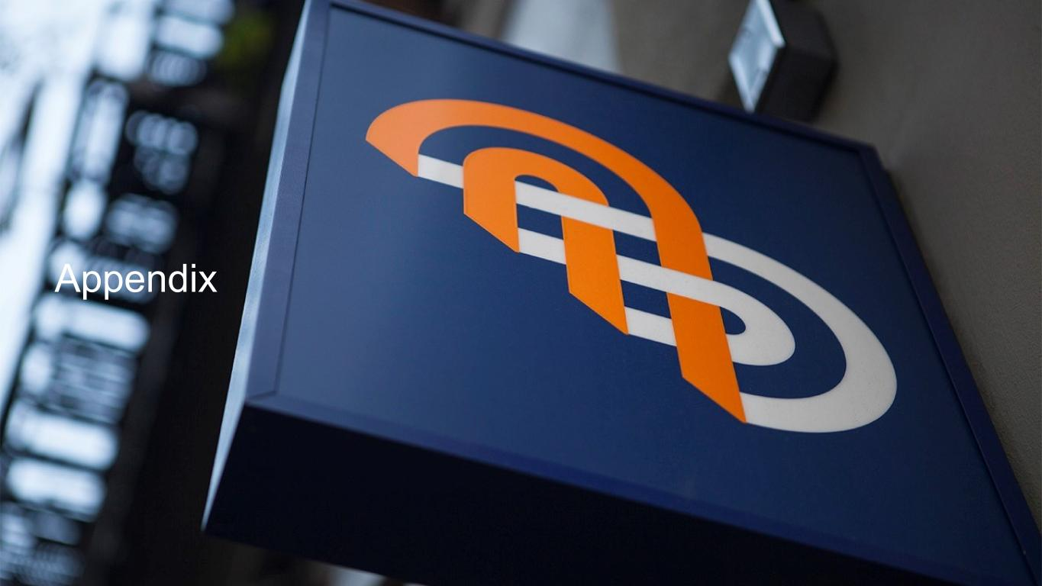
Appendix

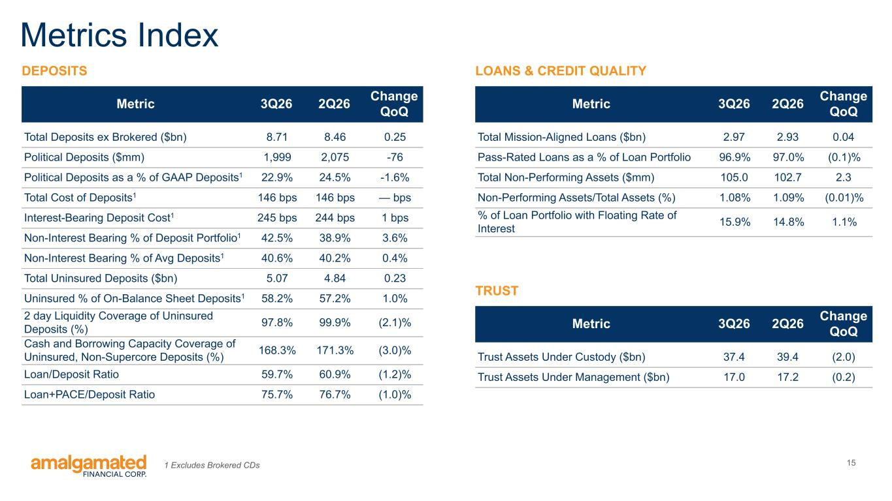
15 Metrics Index DEPOSITS Metric 3Q26 2Q26 Change QoQ Total Deposits ex Brokered ($bn) 8.71 8.46 0.25 Political Deposits ($mm) 1,999 2,075 -76 Political Deposits as a % of GAAP Deposits1 22.9% 24.5% -1.6% Total Cost of Deposits1 146 bps 146 bps — bps Interest-Bearing Deposit Cost1 245 bps 244 bps 1 bps Non-Interest Bearing % of Deposit Portfolio1 42.5% 38.9% 3.6% Non-Interest Bearing % of Avg Deposits1 40.6% 40.2% 0.4% Total Uninsured Deposits ($bn) 5.07 4.84 0.23 Uninsured % of On-Balance Sheet Deposits1 58.2% 57.2% 1.0% 2 day Liquidity Coverage of Uninsured Deposits (%) 97.8% 99.9% (2.1)% Cash and Borrowing Capacity Coverage of Uninsured, Non-Supercore Deposits (%) 168.3% 171.3% (3.0)% Loan/Deposit Ratio 59.7% 60.9% (1.2)% Loan+PACE/Deposit Ratio 75.7% 76.7% (1.0)% Metric 3Q26 2Q26 Change QoQ Total Mission-Aligned Loans ($bn) 2.97 2.93 0.04 Pass-Rated Loans as a % of Loan Portfolio 96.9% 97.0% (0.1)% Total Non-Performing Assets ($mm) 105.0 102.7 2.3 Non-Performing Assets/Total Assets (%) 1.08% 1.09% (0.01)% % of Loan Portfolio with Floating Rate of Interest 15.9% 14.8% 1.1% LOANS & CREDIT QUALITY Metric 3Q26 2Q26 Change QoQ Trust Assets Under Custody ($bn) 37.4 39.4 (2.0) Trust Assets Under Management ($bn) 17.0 17.2 (0.2) TRUST 1 Excludes Brokered CDs

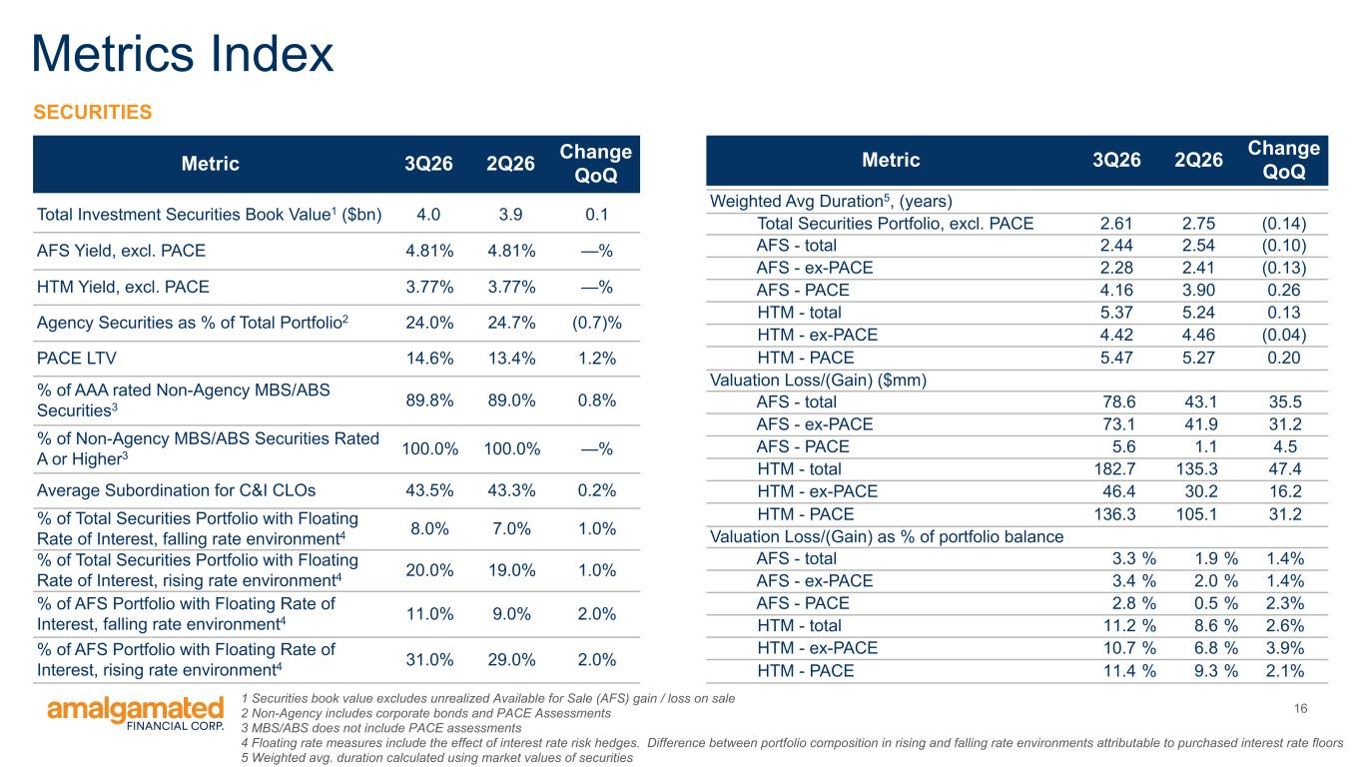
16 Metrics Index Metric 3Q26 2Q26 Change QoQ Total Investment Securities Book Value1 ($bn) 4.0 3.9 0.1 AFS Yield, excl. PACE 4.81% 4.81% —% HTM Yield, excl. PACE 3.77% 3.77% —% Agency Securities as % of Total Portfolio2 24.0% 24.7% (0.7)% PACE LTV 14.6% 13.4% 1.2% % of AAA rated Non-Agency MBS/ABS Securities3 89.8% 89.0% 0.8% % of Non-Agency MBS/ABS Securities Rated A or Higher3 100.0% 100.0% —% Average Subordination for C&I CLOs 43.5% 43.3% 0.2% % of Total Securities Portfolio with Floating Rate of Interest, falling rate environment4 8.0% 7.0% 1.0% % of Total Securities Portfolio with Floating Rate of Interest, rising rate environment4 20.0% 19.0% 1.0% % of AFS Portfolio with Floating Rate of Interest, falling rate environment4 11.0% 9.0% 2.0% % of AFS Portfolio with Floating Rate of Interest, rising rate environment4 31.0% 29.0% 2.0% SECURITIES Metric 3Q26 2Q26 Change QoQ Weighted Avg Duration5, (years) Total Securities Portfolio, excl. PACE 2.61 2.75 (0.14) AFS - total 2.44 2.54 (0.10) AFS - ex-PACE 2.28 2.41 (0.13) AFS - PACE 4.16 3.90 0.26 HTM - total 5.37 5.24 0.13 HTM - ex-PACE 4.42 4.46 (0.04) HTM - PACE 5.47 5.27 0.20 Valuation Loss/(Gain) ($mm) AFS - total 78.6 43.1 35.5 AFS - ex-PACE 73.1 41.9 31.2 AFS - PACE 5.6 1.1 4.5 HTM - total 182.7 135.3 47.4 HTM - ex-PACE 46.4 30.2 16.2 HTM - PACE 136.3 105.1 31.2 Valuation Loss/(Gain) as % of portfolio balance AFS - total 3.3 % 1.9 % 1.4% AFS - ex-PACE 3.4 % 2.0 % 1.4% AFS - PACE 2.8 % 0.5 % 2.3% HTM - total 11.2 % 8.6 % 2.6% HTM - ex-PACE 10.7 % 6.8 % 3.9% HTM - PACE 11.4 % 9.3 % 2.1% 1 Securities book value excludes unrealized Available for Sale (AFS) gain / loss on sale 2 Non-Agency includes corporate bonds and PACE Assessments 3 MBS/ABS does not include PACE assessments 4 Floating rate measures include the effect of interest rate risk hedges. Difference between portfolio composition in rising and falling rate environments attributable to purchased interest rate floors 5 Weighted avg. duration calculated using market values of securities

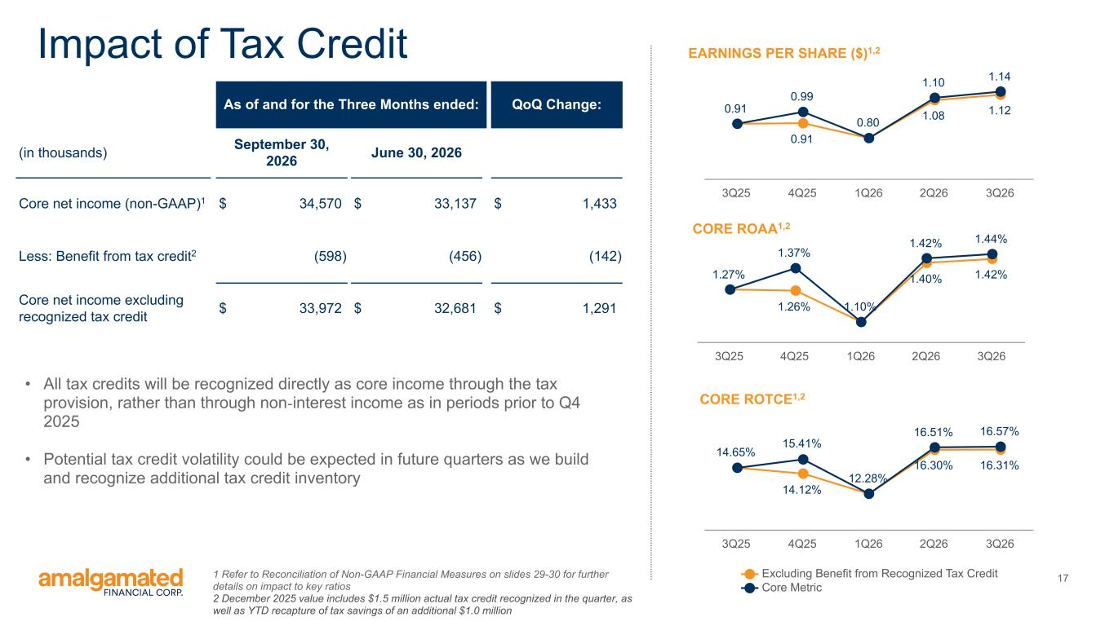
17 1.26% 1.40% 1.42%1.27% 1.37% 1.10% 1.42% 1.44% 3Q25 4Q25 1Q26 2Q26 3Q26 14.12% 16.30% 16.31% 14.65% 15.41% 12.28% 16.51% 16.57% Excluding Benefit from Recognized Tax Credit Core Metric 3Q25 4Q25 1Q26 2Q26 3Q26 CORE ROAA1,2 EARNINGS PER SHARE ($)1,2Impact of Tax Credit 1 Refer to Reconciliation of Non-GAAP Financial Measures on slides 29-30 for further details on impact to key ratios 2 December 2025 value includes $1.5 million actual tax credit recognized in the quarter, as well as YTD recapture of tax savings of an additional $1.0 million CORE ROTCE1,2 0.91 0.91 1.08 1.12 0.99 0.80 1.10 1.14 3Q25 4Q25 1Q26 2Q26 3Q26 As of and for the Three Months ended: QoQ Change: (in thousands) September 30, 2026 June 30, 2026 Core net income (non-GAAP)1 $ 34,570 $ 33,137 $ 1,433 Less: Benefit from tax credit2 (598) (456) (142) Core net income excluding recognized tax credit $ 33,972 $ 32,681 $ 1,291 • All tax credits will be recognized directly as core income through the tax provision, rather than through non-interest income as in periods prior to Q4 2025 • Potential tax credit volatility could be expected in future quarters as we build and recognize additional tax credit inventory

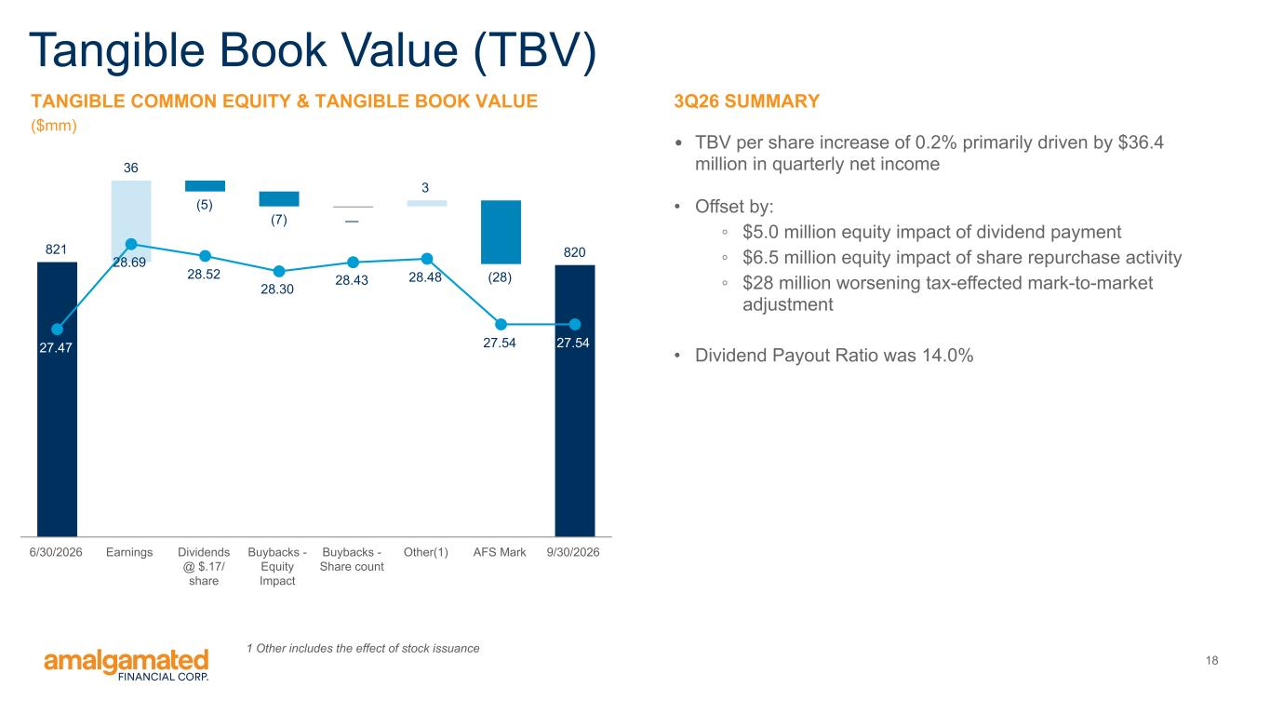
18 821 36 (5) (7) — 3 (28) 820 27.47 28.69 28.52 28.30 28.43 28.48 27.54 27.54 6/30/2026 Earnings Dividends @ $.17/ share Buybacks - Equity Impact Buybacks - Share count Other(1) AFS Mark 9/30/2026 3Q26 SUMMARY • TBV per share increase of 0.2% primarily driven by $36.4 million in quarterly net income • Offset by: ◦ $5.0 million equity impact of dividend payment ◦ $6.5 million equity impact of share repurchase activity ◦ $28 million worsening tax-effected mark-to-market adjustment • Dividend Payout Ratio was 14.0% Tangible Book Value (TBV) TANGIBLE COMMON EQUITY & TANGIBLE BOOK VALUE ($mm) 1 Other includes the effect of stock issuance

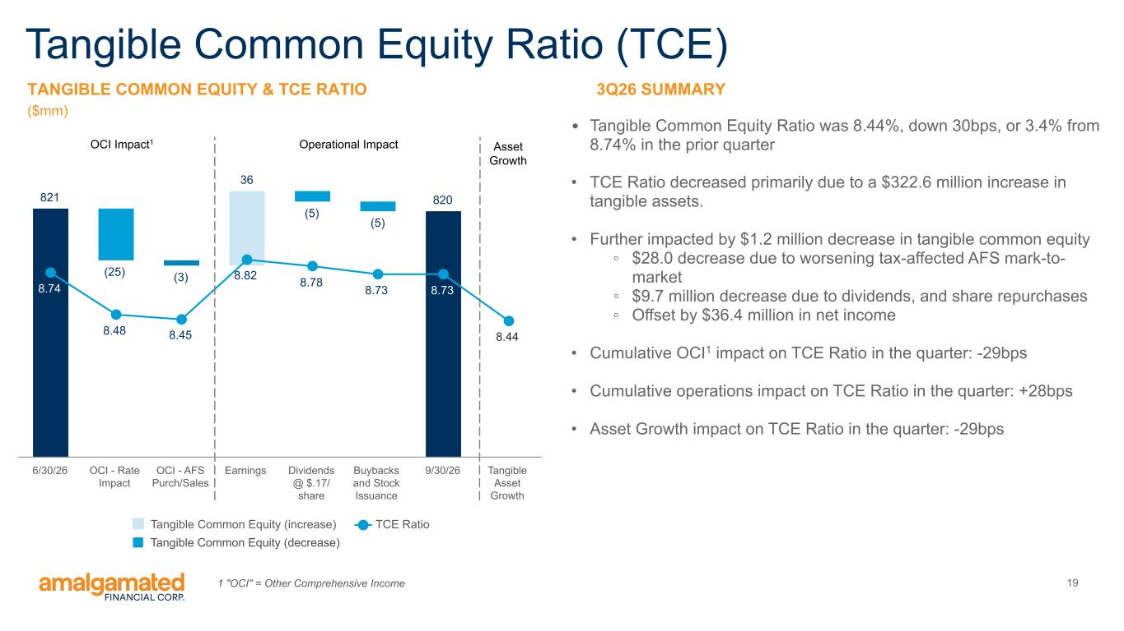
19 821 (25) (3) 36 (5) (5) 820 8.74 8.48 8.45 8.82 8.78 8.73 8.73 8.44 Tangible Common Equity (increase) TCE Ratio 6/30/26 OCI - Rate Impact OCI - AFS Purch/Sales Earnings Dividends @ $.17/ share Buybacks and Stock Issuance 9/30/26 Tangible Asset Growth 3Q26 SUMMARY • Tangible Common Equity Ratio was 8.44%, down 30bps, or 3.4% from 8.74% in the prior quarter • TCE Ratio decreased primarily due to a $322.6 million increase in tangible assets. • Further impacted by $1.2 million decrease in tangible common equity ◦ $28.0 decrease due to worsening tax-affected AFS mark-to- market ◦ $9.7 million decrease due to dividends, and share repurchases ◦ Offset by $36.4 million in net income • Cumulative OCI1 impact on TCE Ratio in the quarter: -29bps • Cumulative operations impact on TCE Ratio in the quarter: +28bps • Asset Growth impact on TCE Ratio in the quarter: -29bps Tangible Common Equity Ratio (TCE) TANGIBLE COMMON EQUITY & TCE RATIO ($mm) Operational ImpactOCI Impact1 Asset Growth 1 "OCI" = Other Comprehensive Income Tangible Common Equity (decrease)

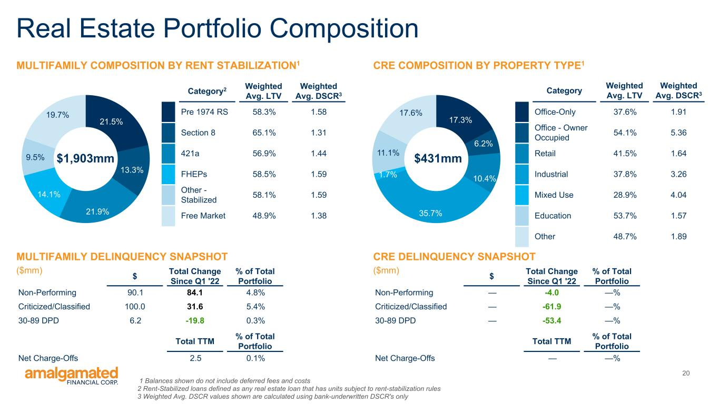
20 21.5% 13.3% 21.9% 14.1% 9.5% 19.7% Real Estate Portfolio Composition 17.3% 6.2% 10.4% 35.7% 1.7% 11.1% 17.6% CRE COMPOSITION BY PROPERTY TYPE1MULTIFAMILY COMPOSITION BY RENT STABILIZATION1 Category2 Weighted Avg. LTV Weighted Avg. DSCR3 Pre 1974 RS 58.3% 1.58 Section 8 65.1% 1.31 421a 56.9% 1.44 FHEPs 58.5% 1.59 Other - Stabilized 58.1% 1.59 Free Market 48.9% 1.38 Category Weighted Avg. LTV Weighted Avg. DSCR3 Office-Only 37.6% 1.91 Office - Owner Occupied 54.1% 5.36 Retail 41.5% 1.64 Industrial 37.8% 3.26 Mixed Use 28.9% 4.04 Education 53.7% 1.57 Other 48.7% 1.89 $431mm$1,903mm MULTIFAMILY DELINQUENCY SNAPSHOT ($mm) CRE DELINQUENCY SNAPSHOT ($mm)$ Total Change Since Q1 '22 % of Total Portfolio Non-Performing 90.1 84.1 4.8% Criticized/Classified 100.0 31.6 5.4% 30-89 DPD 6.2 -19.8 0.3% Total TTM % of Total Portfolio Net Charge-Offs 2.5 0.1% $ Total Change Since Q1 '22 % of Total Portfolio Non-Performing — -4.0 —% Criticized/Classified — -61.9 —% 30-89 DPD — -53.4 —% Total TTM % of Total Portfolio Net Charge-Offs — —% 1 Balances shown do not include deferred fees and costs 2 Rent-Stabilized loans defined as any real estate loan that has units subject to rent-stabilization rules 3 Weighted Avg. DSCR values shown are calculated using bank-underwritten DSCR's only

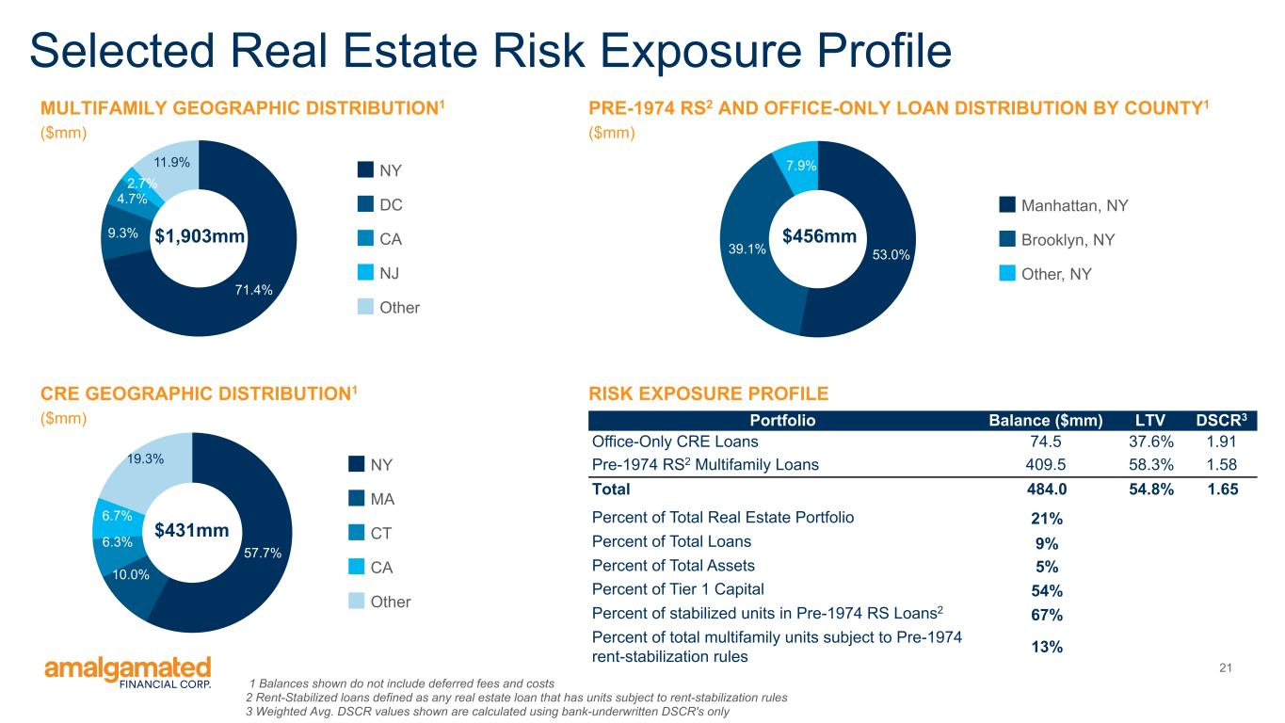
21 Selected Real Estate Risk Exposure Profile RISK EXPOSURE PROFILE PRE-1974 RS2 AND OFFICE-ONLY LOAN DISTRIBUTION BY COUNTY1 ($mm) 53.0%39.1% 7.9% Manhattan, NY Brooklyn, NY Other, NY $456mm Portfolio Balance ($mm) LTV DSCR3 Office-Only CRE Loans 74.5 37.6% 1.91 Pre-1974 RS2 Multifamily Loans 409.5 58.3% 1.58 Total 484.0 54.8% 1.65 Percent of Total Real Estate Portfolio 21% Percent of Total Loans 9% Percent of Total Assets 5% Percent of Tier 1 Capital 54% Percent of stabilized units in Pre-1974 RS Loans2 67% Percent of total multifamily units subject to Pre-1974 rent-stabilization rules 13% 1 Balances shown do not include deferred fees and costs 2 Rent-Stabilized loans defined as any real estate loan that has units subject to rent-stabilization rules 3 Weighted Avg. DSCR values shown are calculated using bank-underwritten DSCR's only MULTIFAMILY GEOGRAPHIC DISTRIBUTION1 ($mm) 71.4% 9.3% 4.7% 2.7% 11.9% NY DC CA NJ Other $1,903mm CRE GEOGRAPHIC DISTRIBUTION1 ($mm) 57.7% 10.0% 6.3% 6.7% 19.3% NY MA CT CA Other $431mm

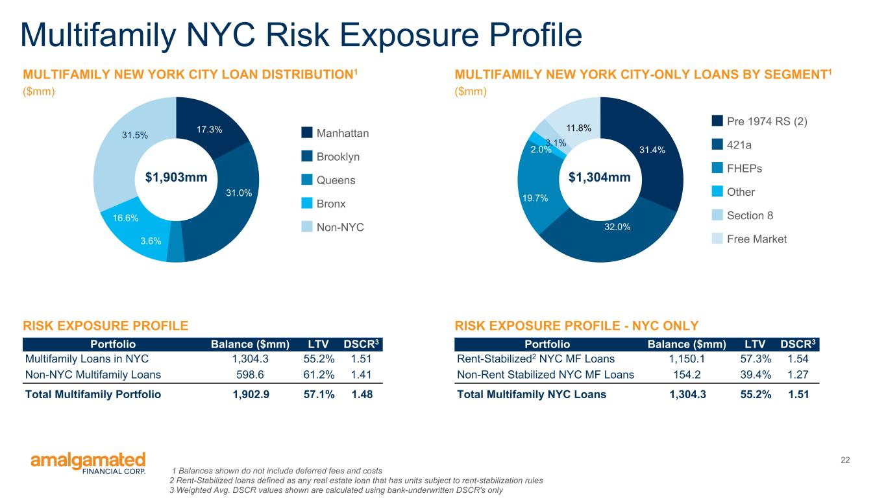
22 Multifamily NYC Risk Exposure Profile 1 Balances shown do not include deferred fees and costs 2 Rent-Stabilized loans defined as any real estate loan that has units subject to rent-stabilization rules 3 Weighted Avg. DSCR values shown are calculated using bank-underwritten DSCR's only RISK EXPOSURE PROFILE MULTIFAMILY NEW YORK CITY LOAN DISTRIBUTION1 ($mm) 17.3% 31.0% 3.6% 16.6% 31.5% Manhattan Brooklyn Queens Bronx Non-NYC $1,903mm Portfolio Balance ($mm) LTV DSCR3 Multifamily Loans in NYC 1,304.3 55.2% 1.51 Non-NYC Multifamily Loans 598.6 61.2% 1.41 Total Multifamily Portfolio 1,902.9 57.1% 1.48 RISK EXPOSURE PROFILE - NYC ONLY MULTIFAMILY NEW YORK CITY-ONLY LOANS BY SEGMENT1 ($mm) 31.4% 32.0% 19.7% 2.0% 3.1% 11.8% Pre 1974 RS (2) 421a FHEPs Other Section 8 Free Market $1,304mm Portfolio Balance ($mm) LTV DSCR3 Rent-Stabilized2 NYC MF Loans 1,150.1 57.3% 1.54 Non-Rent Stabilized NYC MF Loans 154.2 39.4% 1.27 Total Multifamily NYC Loans 1,304.3 55.2% 1.51

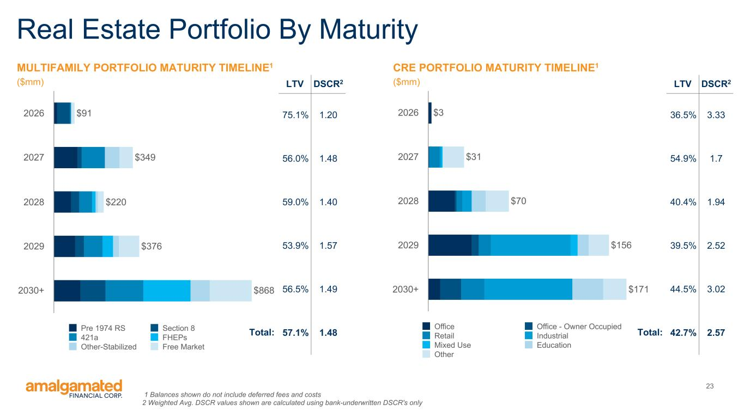
23 Real Estate Portfolio By Maturity MULTIFAMILY PORTFOLIO MATURITY TIMELINE1 ($mm) $91 $349 $220 $376 $868 Pre 1974 RS Section 8 421a FHEPs Other-Stabilized Free Market 2026 2027 2028 2029 2030+ CRE PORTFOLIO MATURITY TIMELINE1 ($mm) $3 $31 $70 $156 $171 Office Office - Owner Occupied Retail Industrial Mixed Use Education Other 2026 2027 2028 2029 2030+ LTV DSCR2 75.1% 1.20 56.0% 1.48 59.0% 1.40 53.9% 1.57 56.5% 1.49 57.1% 1.48 LTV DSCR2 36.5% 3.33 54.9% 1.7 40.4% 1.94 39.5% 2.52 44.5% 3.02 42.7% 2.57Total:Total: 1 Balances shown do not include deferred fees and costs 2 Weighted Avg. DSCR values shown are calculated using bank-underwritten DSCR's only

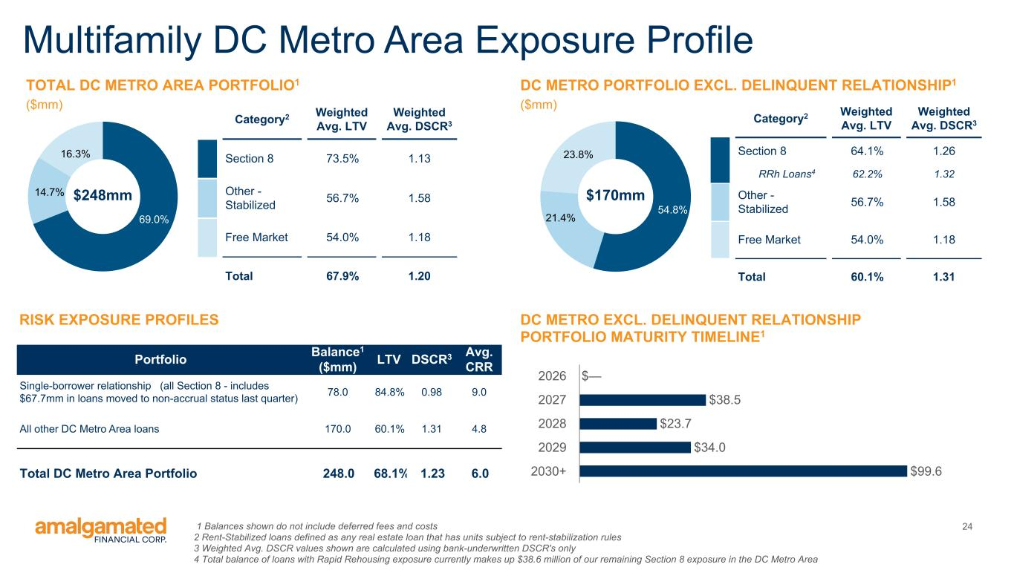
24 Multifamily DC Metro Area Exposure Profile 1 Balances shown do not include deferred fees and costs 2 Rent-Stabilized loans defined as any real estate loan that has units subject to rent-stabilization rules 3 Weighted Avg. DSCR values shown are calculated using bank-underwritten DSCR's only 4 Total balance of loans with Rapid Rehousing exposure currently makes up $38.6 million of our remaining Section 8 exposure in the DC Metro Area RISK EXPOSURE PROFILES TOTAL DC METRO AREA PORTFOLIO1 ($mm) Portfolio Balance1 ($mm) LTV DSCR3 Avg. CRR Single-borrower relationship (all Section 8 - includes $67.7mm in loans moved to non-accrual status last quarter) 78.0 84.8% 0.98 9.0 All other DC Metro Area loans 170.0 60.1% 1.31 4.8 Total DC Metro Area Portfolio 248.0 68.1% 1.23 6.0 DC METRO PORTFOLIO EXCL. DELINQUENT RELATIONSHIP1 ($mm) 69.0% 14.7% 16.3% $248mm Category2 Weighted Avg. LTV Weighted Avg. DSCR3 Section 8 73.5% 1.13 Other - Stabilized 56.7% 1.58 Free Market 54.0% 1.18 Total 67.9% 1.20 54.8% 21.4% 23.8% Category2 Weighted Avg. LTV Weighted Avg. DSCR3 Section 8 64.1% 1.26 RRh Loans4 62.2% 1.32 Other - Stabilized 56.7% 1.58 Free Market 54.0% 1.18 Total 60.1% 1.31 $170mm $— $38.5 $23.7 $34.0 $99.6 2026 2027 2028 2029 2030+ DC METRO EXCL. DELINQUENT RELATIONSHIP PORTFOLIO MATURITY TIMELINE1

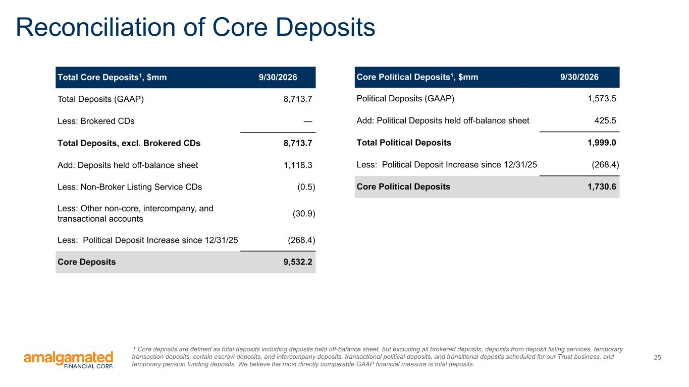
25 Reconciliation of Core Deposits Total Core Deposits1, $mm 9/30/2026 Total Deposits (GAAP) 8,713.7 Less: Brokered CDs — Total Deposits, excl. Brokered CDs 8,713.7 Add: Deposits held off-balance sheet 1,118.3 Less: Non-Broker Listing Service CDs (0.5) Less: Other non-core, intercompany, and transactional accounts (30.9) Less: Political Deposit Increase since 12/31/25 (268.4) Core Deposits 9,532.2 Core Political Deposits1, $mm 9/30/2026 Political Deposits (GAAP) 1,573.5 Add: Political Deposits held off-balance sheet 425.5 Total Political Deposits 1,999.0 Less: Political Deposit Increase since 12/31/25 (268.4) Core Political Deposits 1,730.6 1 Core deposits are defined as total deposits including deposits held off-balance sheet, but excluding all brokered deposits, deposits from deposit listing services, temporary transaction deposits, certain escrow deposits, and intercompany deposits, transactional political deposits, and transitional deposits scheduled for our Trust business, and temporary pension funding deposits. We believe the most directly comparable GAAP financial measure is total deposits.

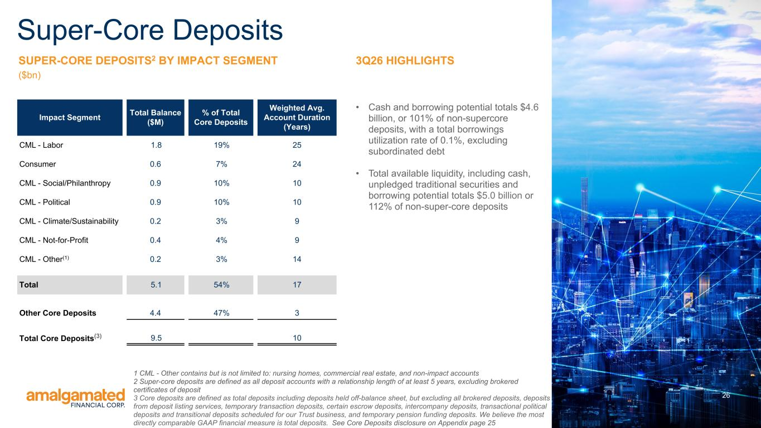
26 SUPER-CORE DEPOSITS2 BY IMPACT SEGMENT ($bn) 3Q26 HIGHLIGHTS • Cash and borrowing potential totals $4.6 billion, or 101% of non-supercore deposits, with a total borrowings utilization rate of 0.1%, excluding subordinated debt • Total available liquidity, including cash, unpledged traditional securities and borrowing potential totals $5.0 billion or 112% of non-super-core deposits Impact Segment Total Balance ($M) % of Total Core Deposits Weighted Avg. Account Duration (Years) CML - Labor 1.8 19% 25 Consumer 0.6 7% 24 CML - Social/Philanthropy 0.9 10% 10 CML - Political 0.9 10% 10 CML - Climate/Sustainability 0.2 3% 9 CML - Not-for-Profit 0.4 4% 9 CML - Other(1) 0.2 3% 14 Total 5.1 54% 17 Other Core Deposits 4.4 47% 3 Total Core Deposits(3) 9.5 10 Super-Core Deposits 1 CML - Other contains but is not limited to: nursing homes, commercial real estate, and non-impact accounts 2 Super-core deposits are defined as all deposit accounts with a relationship length of at least 5 years, excluding brokered certificates of deposit 3 Core deposits are defined as total deposits including deposits held off-balance sheet, but excluding all brokered deposits, deposits from deposit listing services, temporary transaction deposits, certain escrow deposits, intercompany deposits, transactional political deposits and transitional deposits scheduled for our Trust business, and temporary pension funding deposits. We believe the most directly comparable GAAP financial measure is total deposits. See Core Deposits disclosure on Appendix page 25

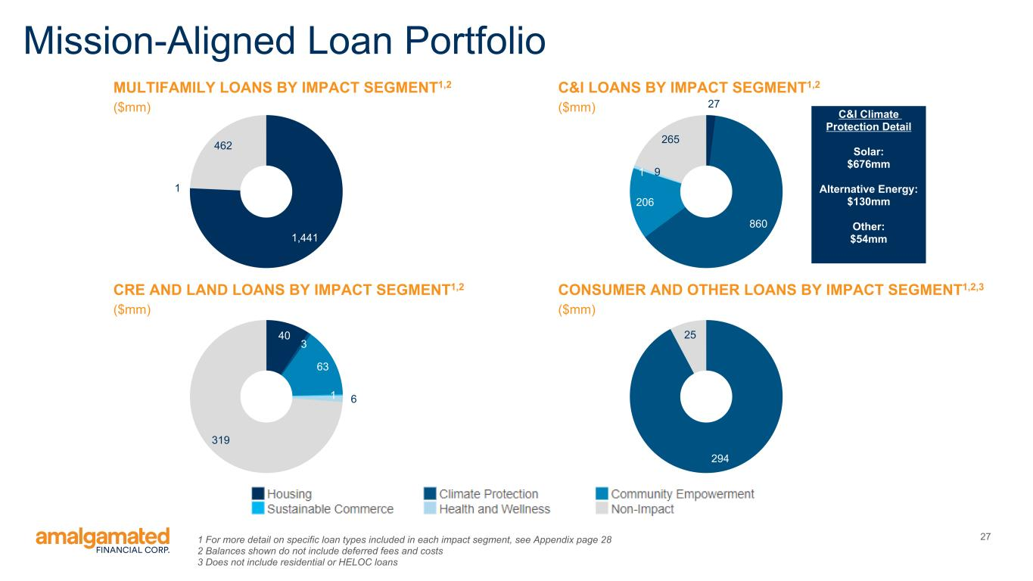
271 For more detail on specific loan types included in each impact segment, see Appendix page 28 2 Balances shown do not include deferred fees and costs 3 Does not include residential or HELOC loans Mission-Aligned Loan Portfolio 1,441 1 462 CRE AND LAND LOANS BY IMPACT SEGMENT1,2 ($mm) 40 3 63 1 6 319 C&I LOANS BY IMPACT SEGMENT1,2 ($mm) 27 860 206 1 9 265 CONSUMER AND OTHER LOANS BY IMPACT SEGMENT1,2,3 ($mm) 294 25 C&I Climate Protection Detail Solar: $676mm Alternative Energy: $130mm Other: $54mm MULTIFAMILY LOANS BY IMPACT SEGMENT1,2 ($mm)

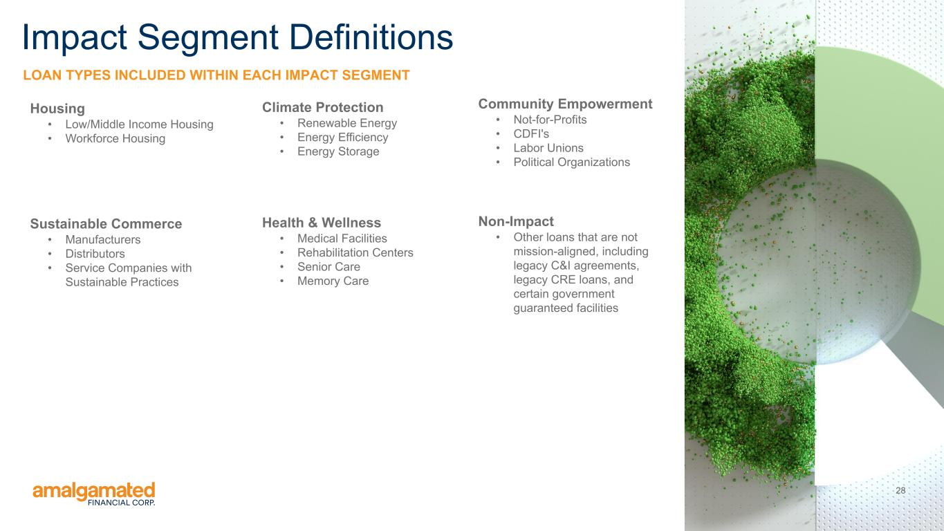
28 LOAN TYPES INCLUDED WITHIN EACH IMPACT SEGMENT Impact Segment Definitions Climate Protection • Renewable Energy • Energy Efficiency • Energy Storage Community Empowerment • Not-for-Profits • CDFI's • Labor Unions • Political Organizations Health & Wellness • Medical Facilities • Rehabilitation Centers • Senior Care • Memory Care Housing • Low/Middle Income Housing • Workforce Housing Sustainable Commerce • Manufacturers • Distributors • Service Companies with Sustainable Practices Non-Impact • Other loans that are not mission-aligned, including legacy C&I agreements, legacy CRE loans, and certain government guaranteed facilities

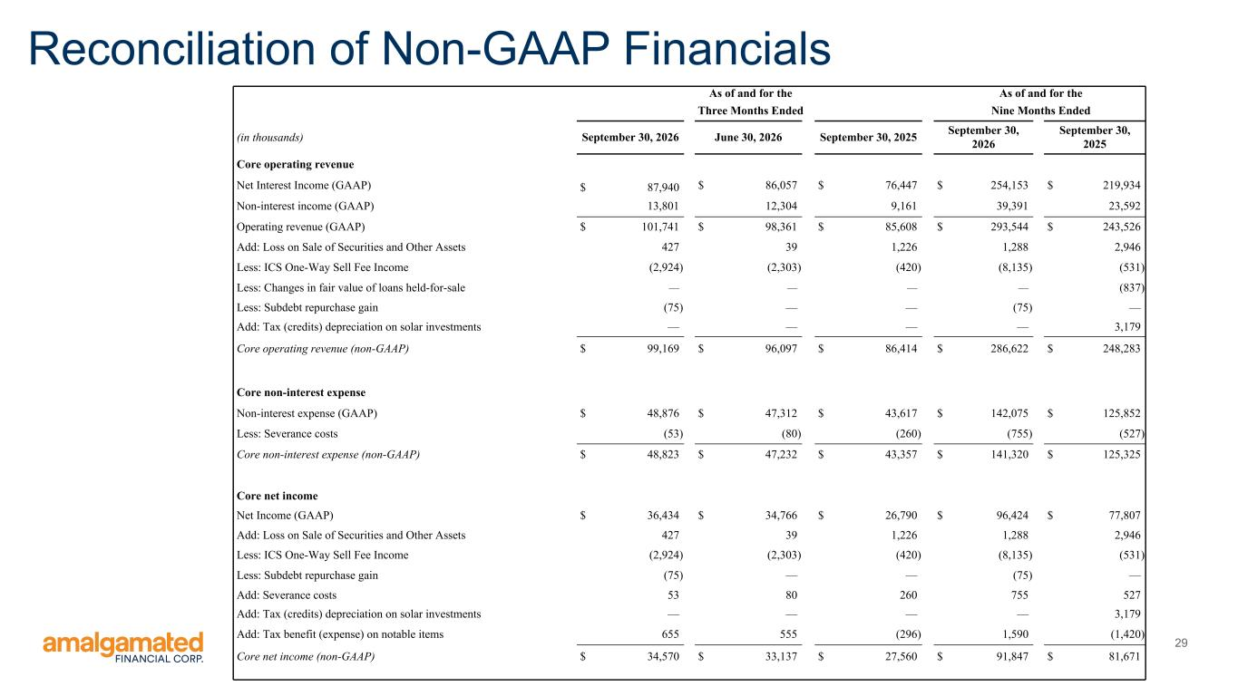
29 Reconciliation of Non-GAAP Financials As of and for the As of and for the Three Months Ended Nine Months Ended (in thousands) September 30, 2026 June 30, 2026 September 30, 2025 September 30, 2026 September 30, 2025 Core operating revenue Net Interest Income (GAAP) $ 87,940 $ 86,057 $ 76,447 $ 254,153 $ 219,934 Non-interest income (GAAP) 13,801 12,304 9,161 39,391 23,592 Operating revenue (GAAP) $ 101,741 $ 98,361 $ 85,608 $ 293,544 $ 243,526 Add: Loss on Sale of Securities and Other Assets 427 39 1,226 1,288 2,946 Less: ICS One-Way Sell Fee Income (2,924) (2,303) (420) (8,135) (531) Less: Changes in fair value of loans held-for-sale — — — — (837) Less: Subdebt repurchase gain (75) — — (75) — Add: Tax (credits) depreciation on solar investments — — — — 3,179 Core operating revenue (non-GAAP) $ 99,169 $ 96,097 $ 86,414 $ 286,622 $ 248,283 Core non-interest expense Non-interest expense (GAAP) $ 48,876 $ 47,312 $ 43,617 $ 142,075 $ 125,852 Less: Severance costs (53) (80) (260) (755) (527) Core non-interest expense (non-GAAP) $ 48,823 $ 47,232 $ 43,357 $ 141,320 $ 125,325 Core net income Net Income (GAAP) $ 36,434 $ 34,766 $ 26,790 $ 96,424 $ 77,807 Add: Loss on Sale of Securities and Other Assets 427 39 1,226 1,288 2,946 Less: ICS One-Way Sell Fee Income (2,924) (2,303) (420) (8,135) (531) Less: Subdebt repurchase gain (75) — — (75) — Add: Severance costs 53 80 260 755 527 Add: Tax (credits) depreciation on solar investments — — — — 3,179 Add: Tax benefit (expense) on notable items 655 555 (296) 1,590 (1,420) Core net income (non-GAAP) $ 34,570 $ 33,137 $ 27,560 $ 91,847 $ 81,671

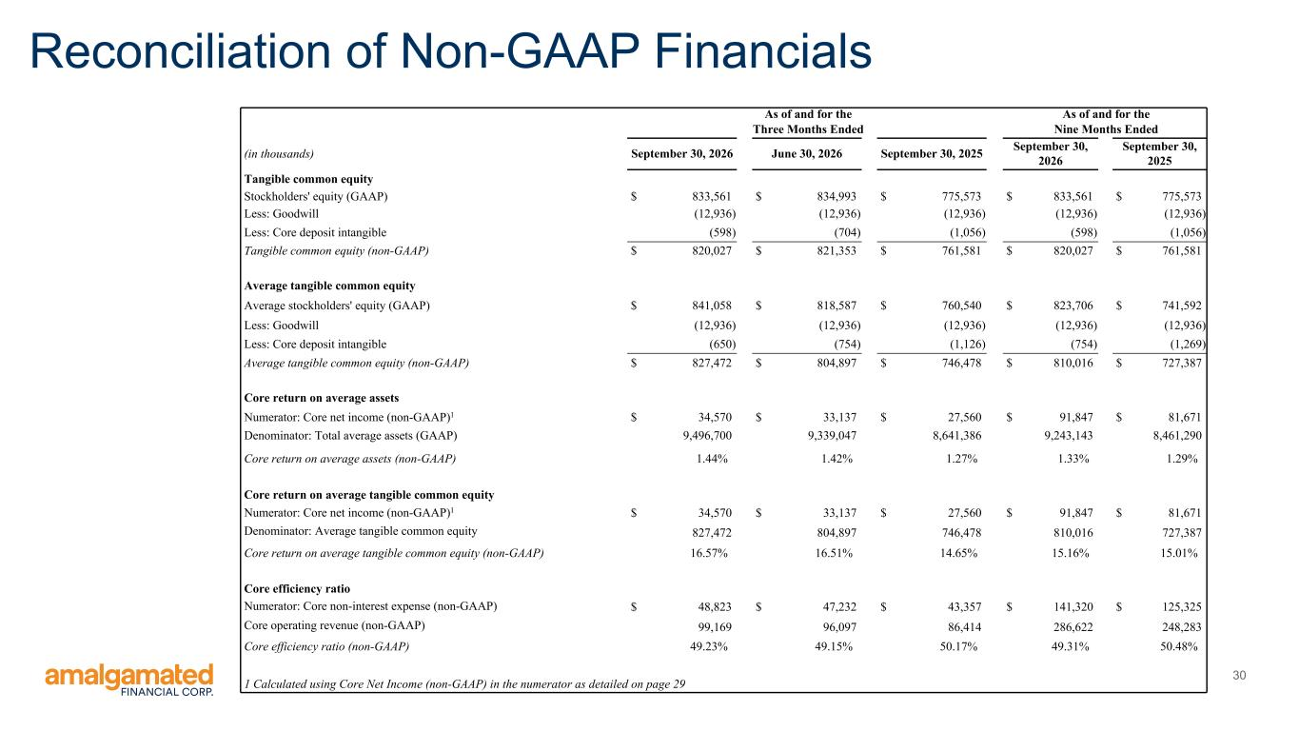
30 Reconciliation of Non-GAAP Financials As of and for the As of and for the Three Months Ended Nine Months Ended (in thousands) September 30, 2026 June 30, 2026 September 30, 2025 September 30, 2026 September 30, 2025 Tangible common equity Stockholders' equity (GAAP) $ 833,561 $ 834,993 $ 775,573 $ 833,561 $ 775,573 Less: Goodwill (12,936) (12,936) (12,936) (12,936) (12,936) Less: Core deposit intangible (598) (704) (1,056) (598) (1,056) Tangible common equity (non-GAAP) $ 820,027 $ 821,353 $ 761,581 $ 820,027 $ 761,581 Average tangible common equity Average stockholders' equity (GAAP) $ 841,058 $ 818,587 $ 760,540 $ 823,706 $ 741,592 Less: Goodwill (12,936) (12,936) (12,936) (12,936) (12,936) Less: Core deposit intangible (650) (754) (1,126) (754) (1,269) Average tangible common equity (non-GAAP) $ 827,472 $ 804,897 $ 746,478 $ 810,016 $ 727,387 Core return on average assets Numerator: Core net income (non-GAAP)1 $ 34,570 $ 33,137 $ 27,560 $ 91,847 $ 81,671 Denominator: Total average assets (GAAP) 9,496,700 9,339,047 8,641,386 9,243,143 8,461,290 Core return on average assets (non-GAAP) 1.44% 1.42% 1.27% 1.33% 1.29% Core return on average tangible common equity Numerator: Core net income (non-GAAP)1 $ 34,570 $ 33,137 $ 27,560 $ 91,847 $ 81,671 Denominator: Average tangible common equity 827,472 804,897 746,478 810,016 727,387 Core return on average tangible common equity (non-GAAP) 16.57% 16.51% 14.65% 15.16% 15.01% Core efficiency ratio Numerator: Core non-interest expense (non-GAAP) $ 48,823 $ 47,232 $ 43,357 $ 141,320 $ 125,325 Core operating revenue (non-GAAP) 99,169 96,097 86,414 286,622 248,283 Core efficiency ratio (non-GAAP) 49.23% 49.15% 50.17% 49.31% 50.48% 1 Calculated using Core Net Income (non-GAAP) in the numerator as detailed on page 29


Thank You amalgamatedbank.com Member FDIC

